**GIT**

git .ignore to hold file that don’t need to be push once they are committed

git stash save project for later use

git push sent file to github

git pull retrieve file fom github

git clone clone a repository

git fetch take file from remote repos to local repos

git log see log of commit file

git tag add a tag to a commit

git reset to revert file that are about to be committed

Git branch -a to list all branches

delete branch locally

git branch -d localBranchName

delete branch remotely

git push origin --delete remoteBranchName

git push origin -d remoteBranchName

git diff show the change on a file

git status show that the file was changed without showing the change

$ git branch branchname to create a new branch

$ git checkout branchname to start working on a branch also take file from local repos to working directory

$git merge take file from local repos to working directory

**Git bisect** is used to find the commit that introduced a bug by using binary search.

**Git Cherry picking** in Git means to choose a commit from one branch and apply it onto another.

The **git stash** command takes your uncommitted changes (both staged and unstaged), saves them away for later use, and then reverts them from your working copy.

**A conflict** arises when two separates branches have made edits to the same line in a file, or when a file has been deleted in one branch but edited in the other. Conflicts will most likely happen when working in a team environment. There are many tools to help resolve merge conflicts.

**git-mergetool** - Run merge conflict resolution tools to resolve merge conflicts

• **git revert** requires the id of the commit **you want to remove** keeping it into your history

• **git reset** requires the commit **you want to keep**, and will consequentially remove anything

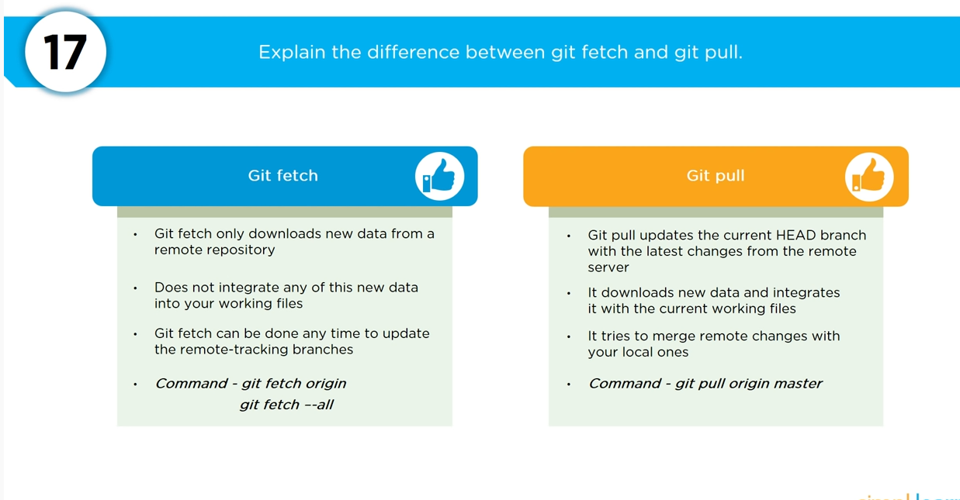

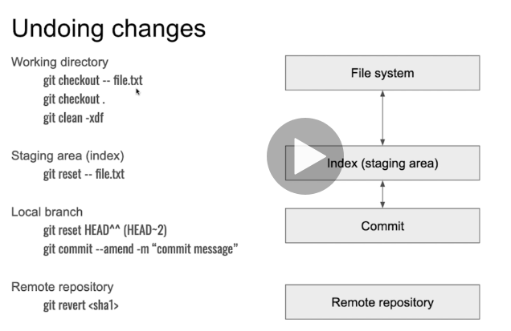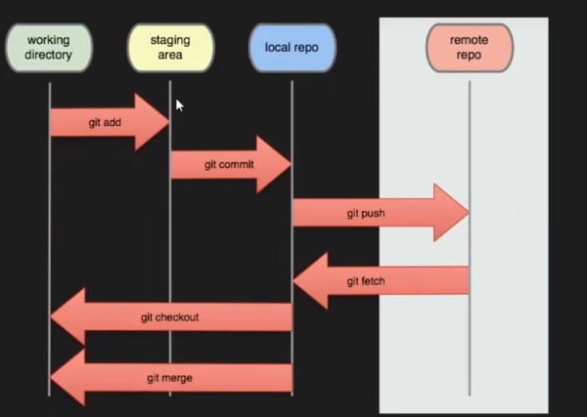

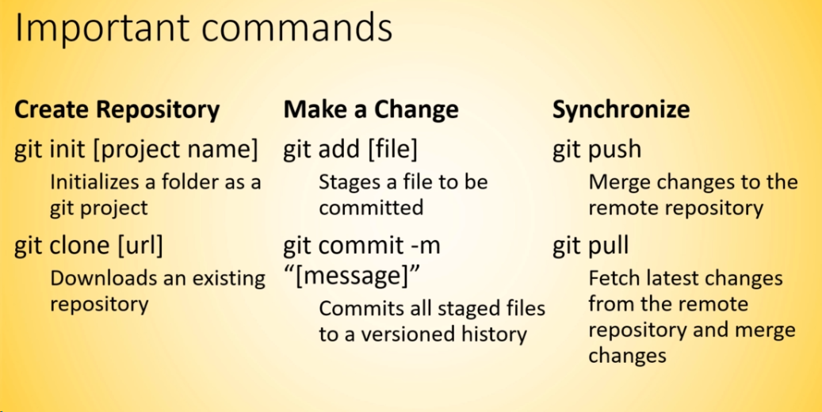

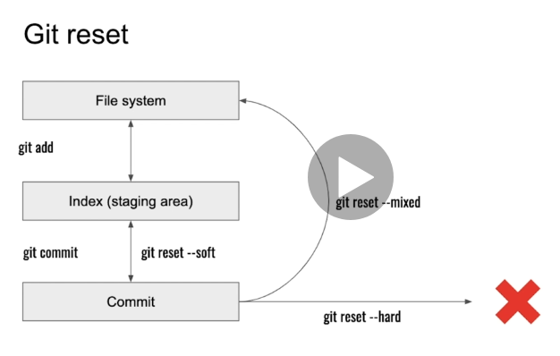git log --pretty=oneline

Specify HEAD~xxxx

**CI/CD**

**What are the advantages of DevOps?**

For this answer, you can use your experience and explain how DevOps helped you in your previous job. If you do not have any such experience, then you can mention the below advantages.

Technical benefits:

* Continuous software delivery
* Less complex problems to fix
* Faster resolution of problems

Business benefits:

* Faster delivery of features
* More stable operating environments
* More time available to add value (rather than fix/maintain)

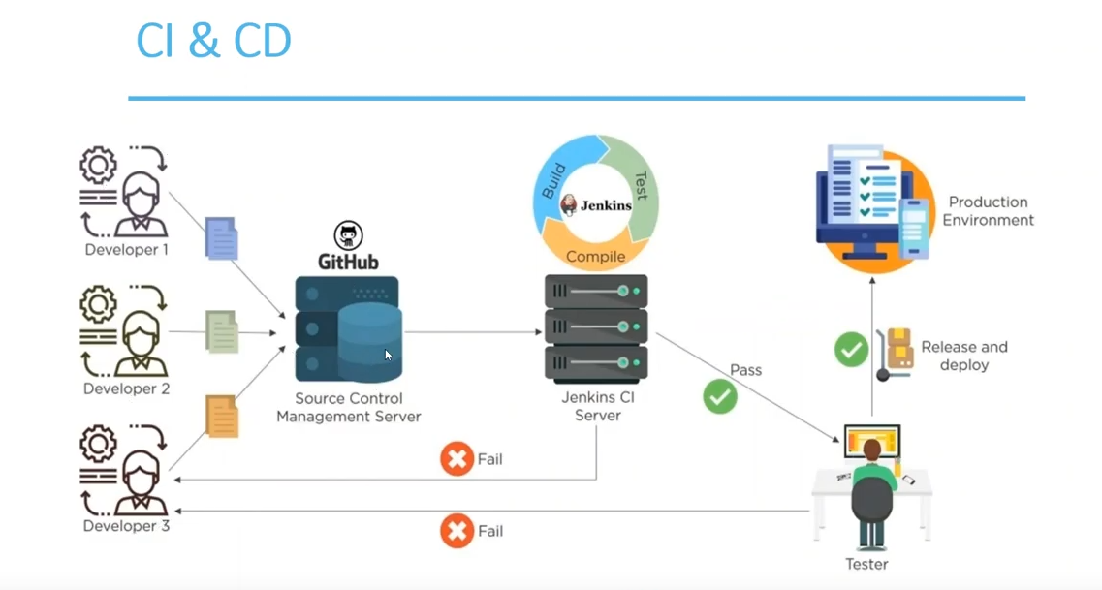

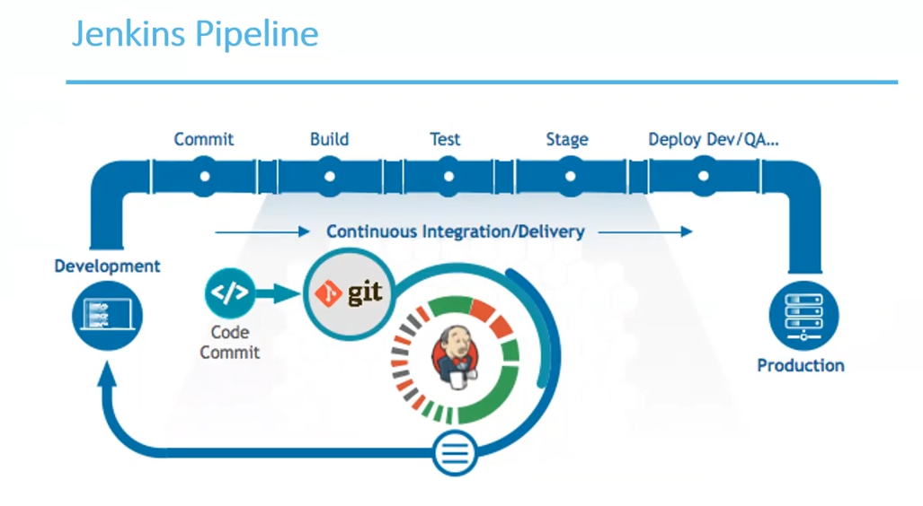

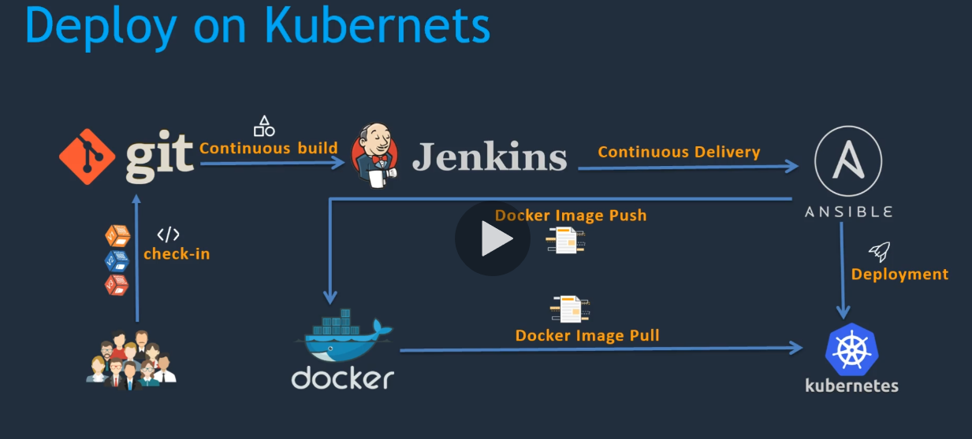

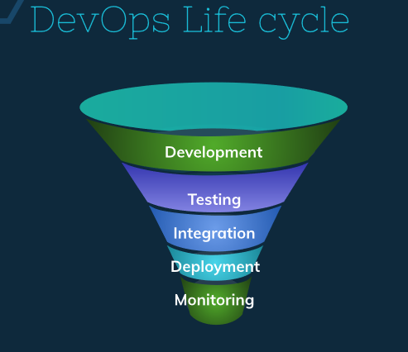

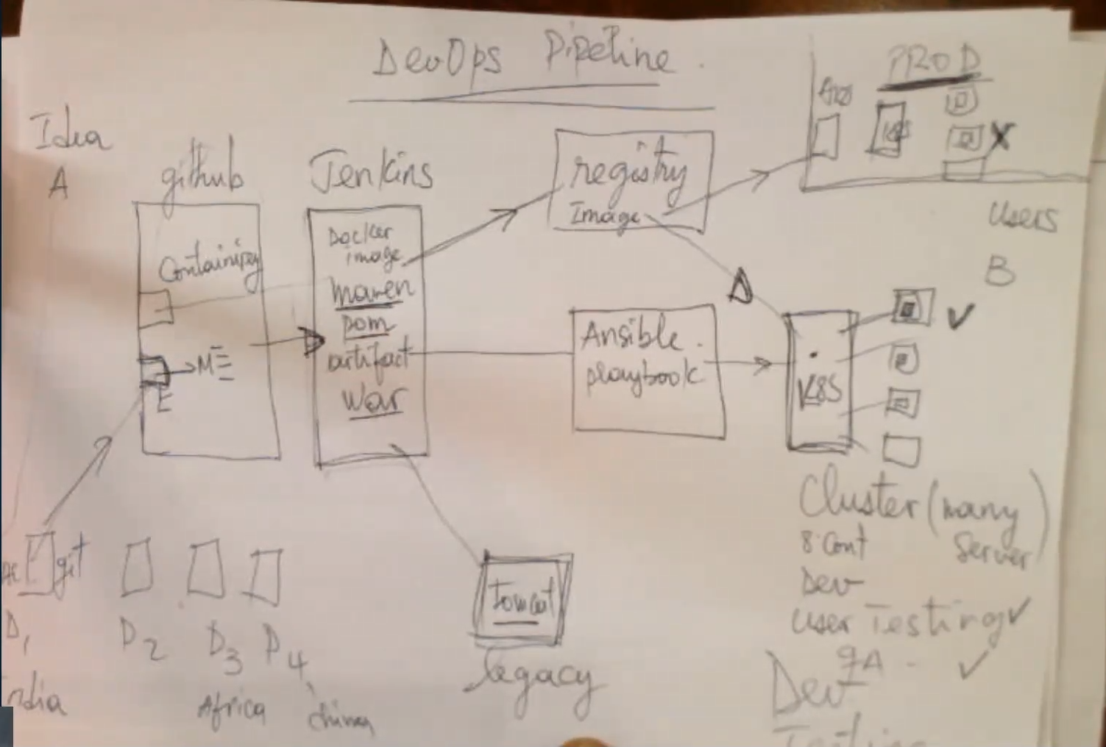

Dev test

User test

Load test

Vulnerability test

Security test

Quality assurance test

Server test

Customer review

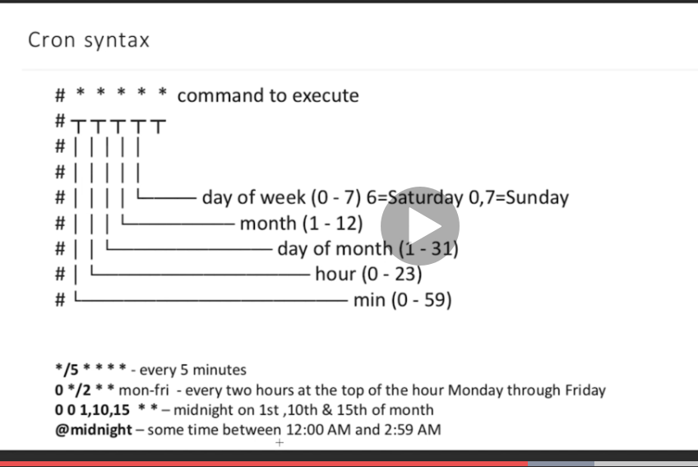

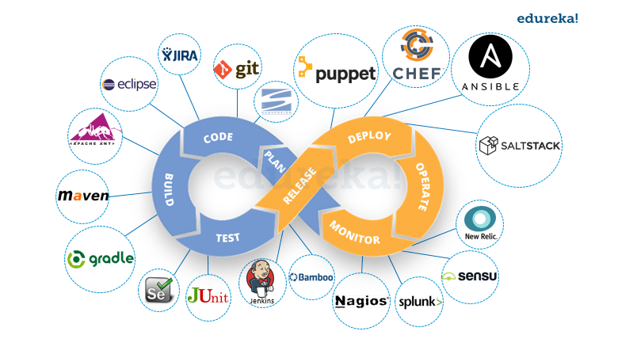

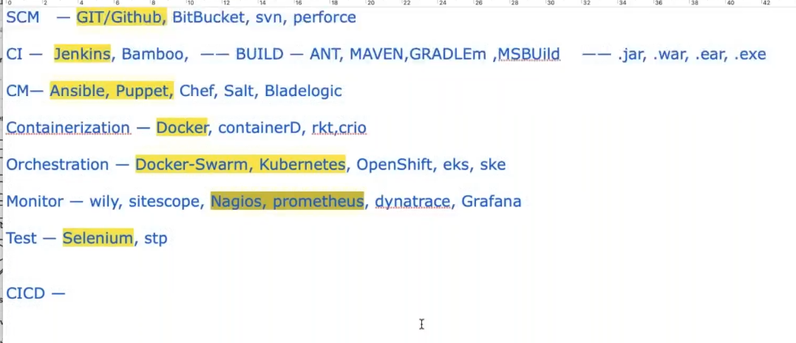

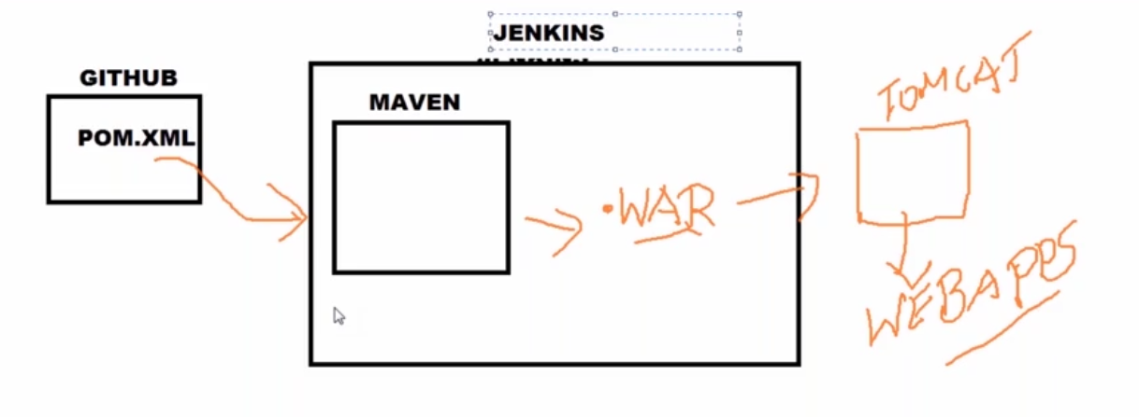

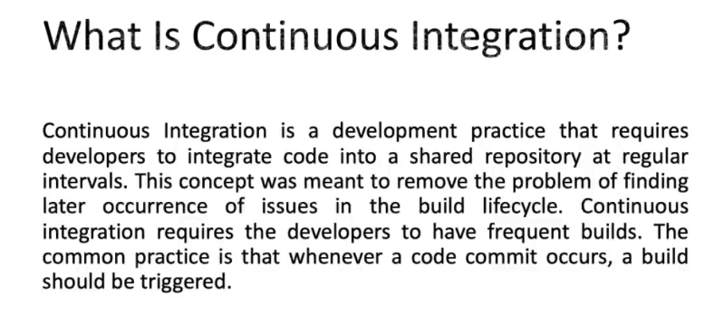

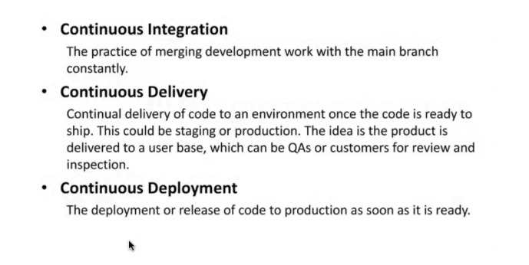

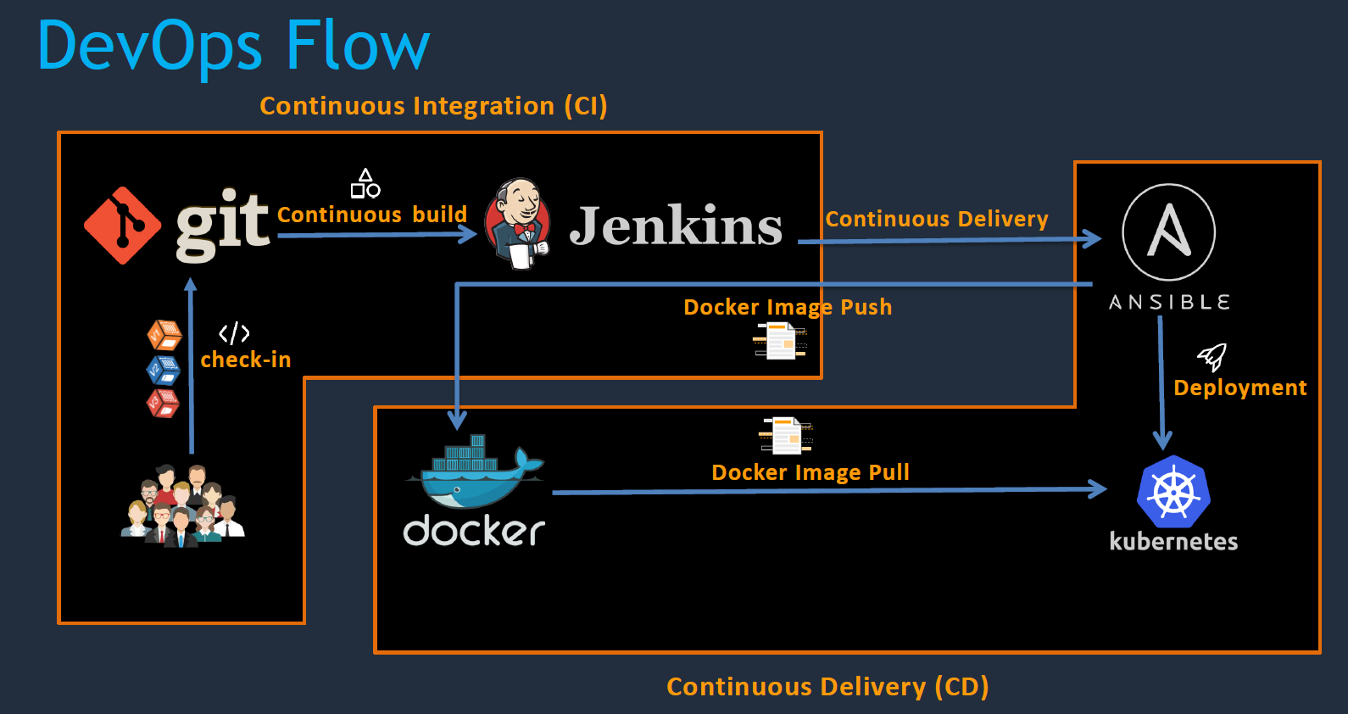

F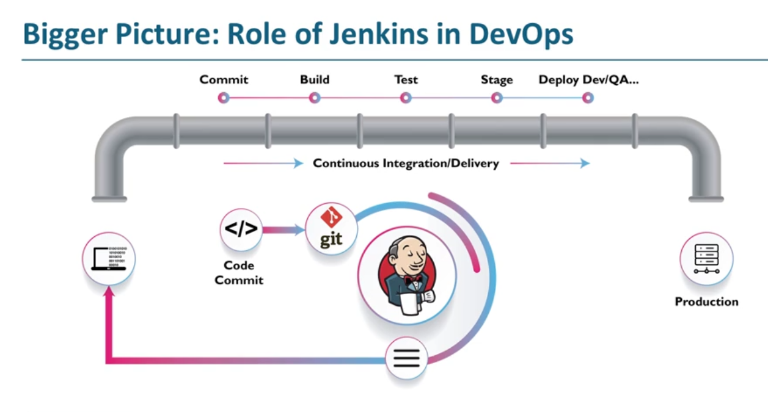

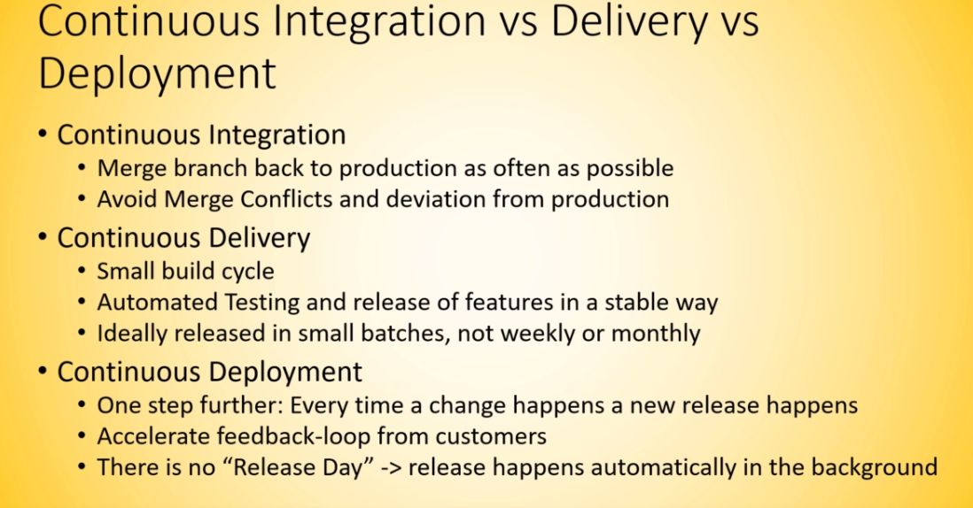

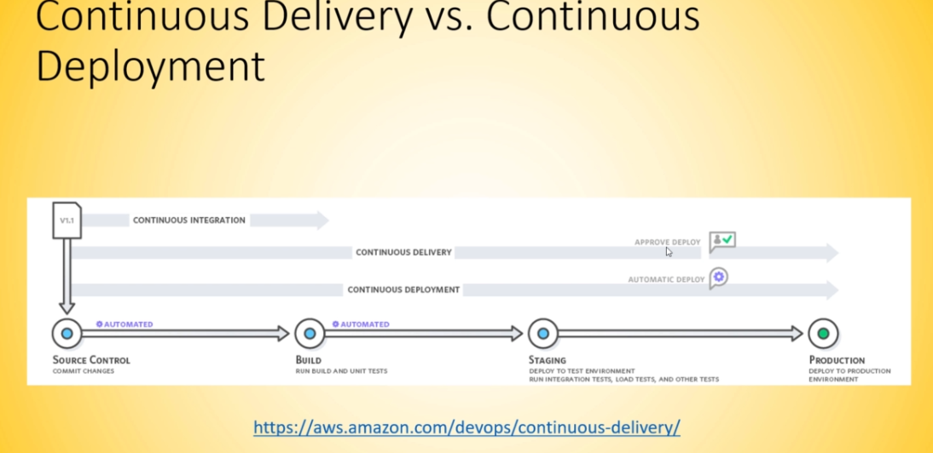 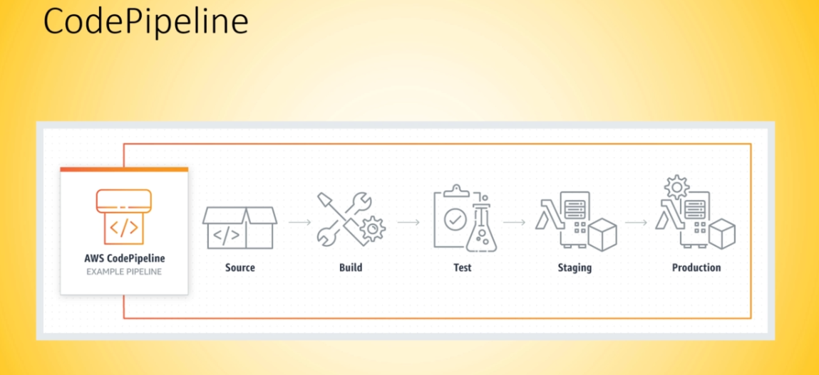

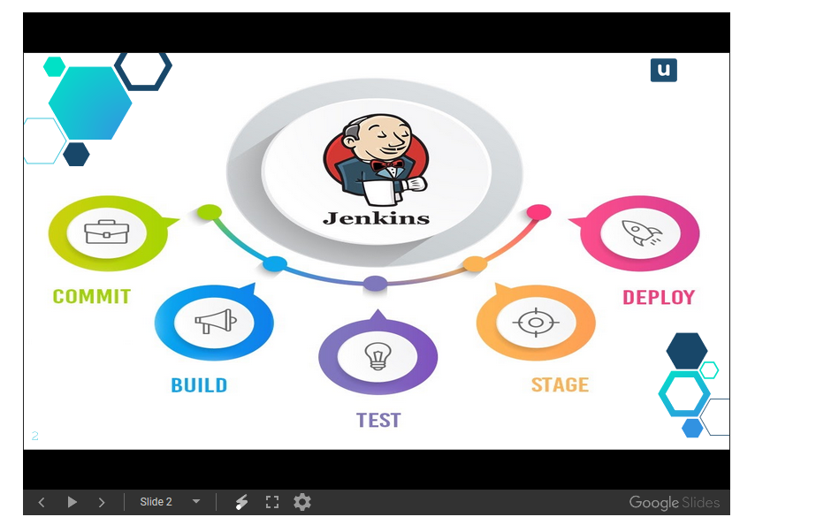

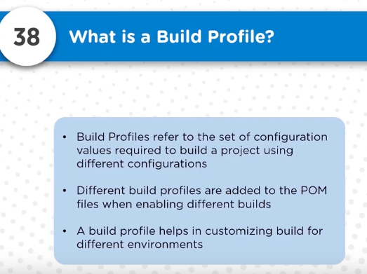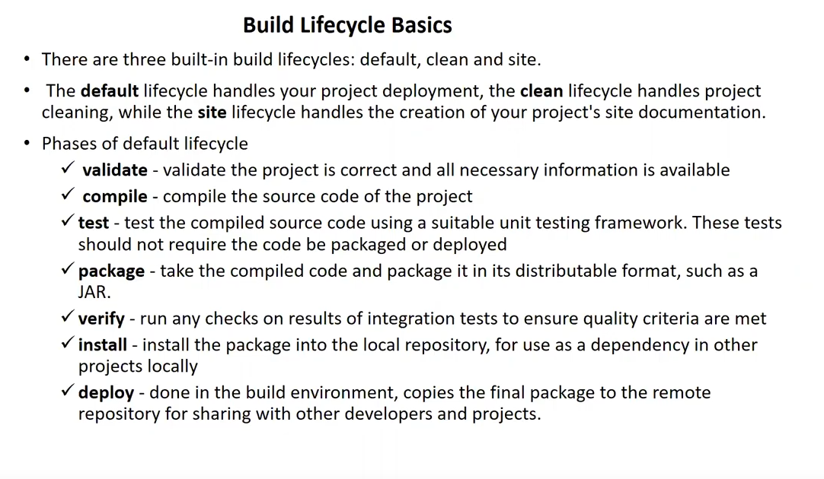 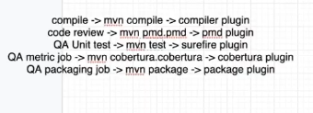

**MAVEN**

**Jenkins Pre-test**

PMD (Programming Mistake Detector) test

Selenium regression test

Java unit test

Metric testing

End to end test

cobertura:cobertura -Dcobertura.report.format=xml

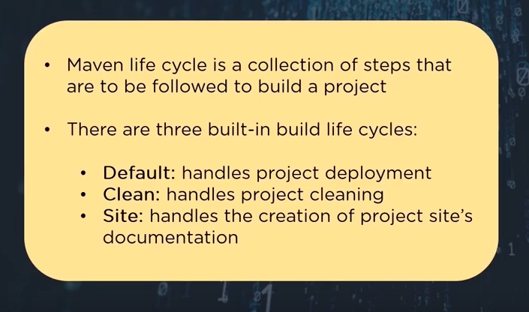

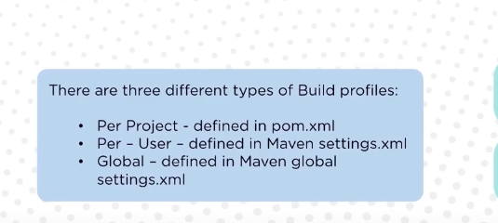I

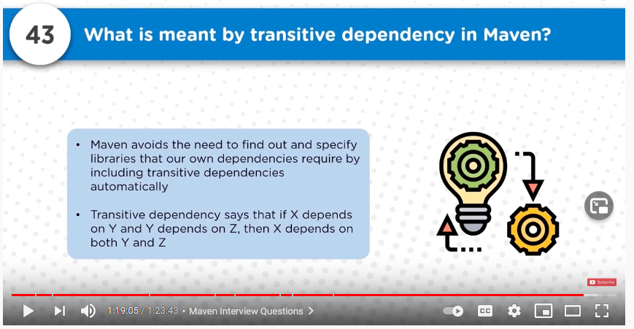

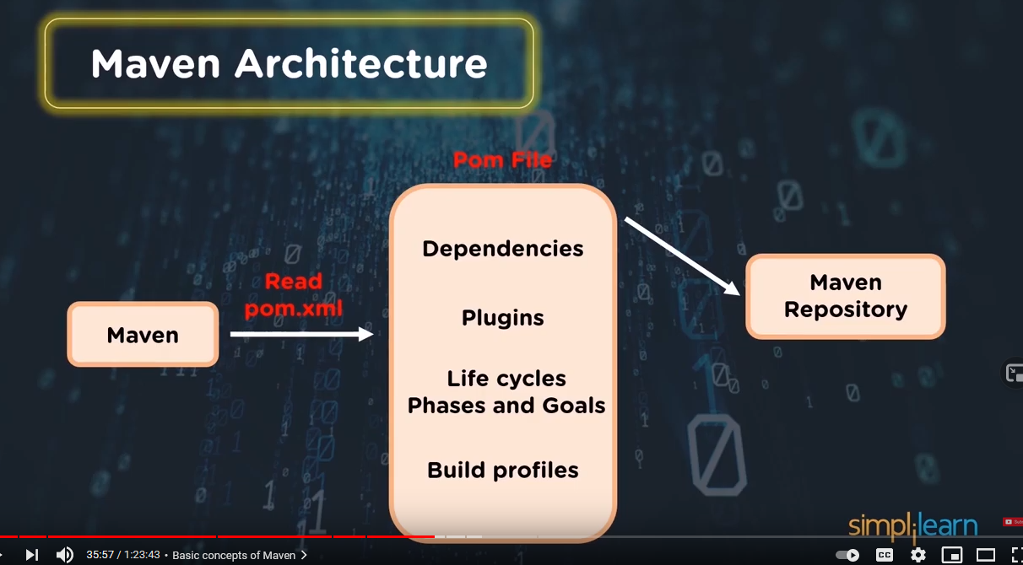

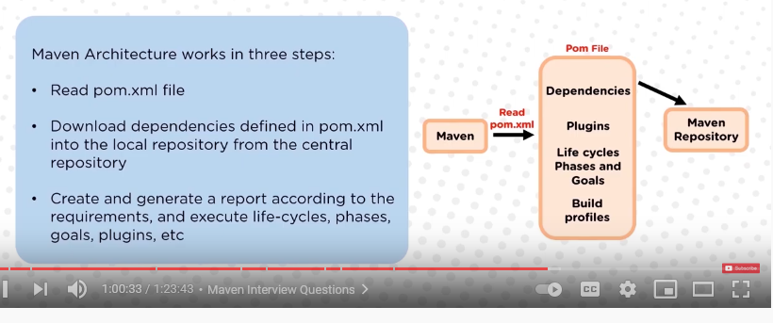

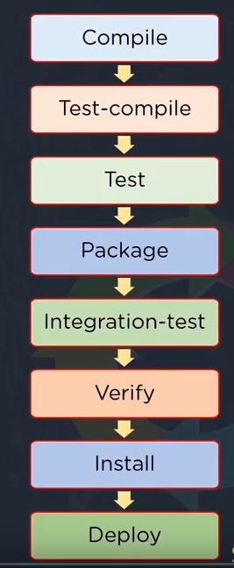

If you want to specify the specific repository where maven should download the dependencies it need to be configure in .m2 folder in setting.xml of maven also it cans be specify in POM file

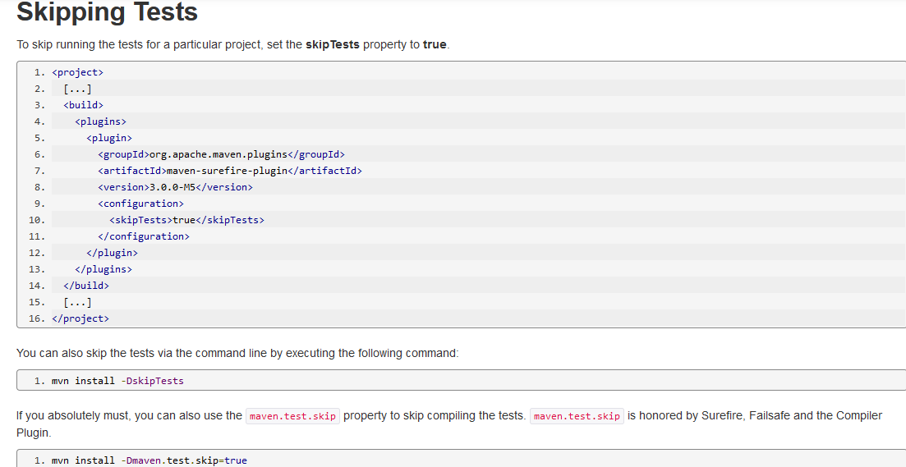

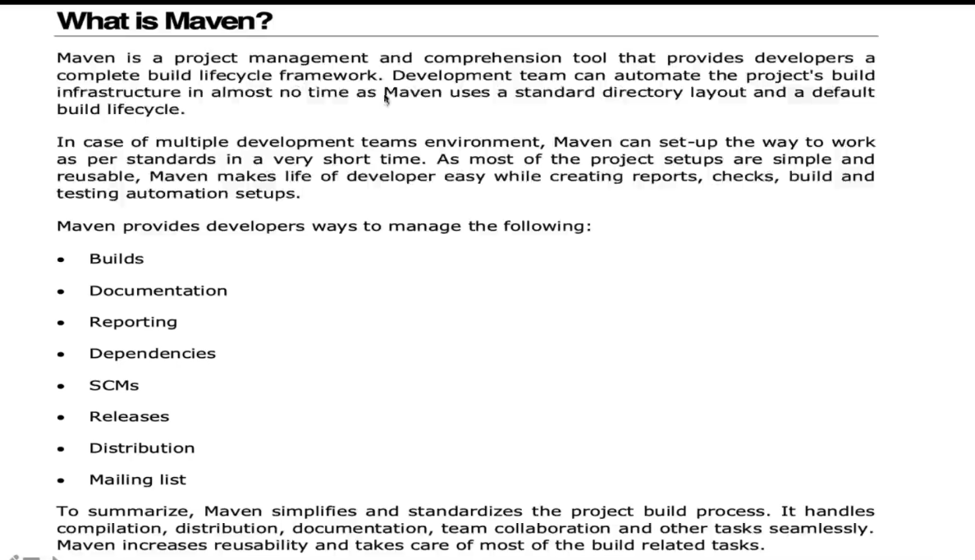

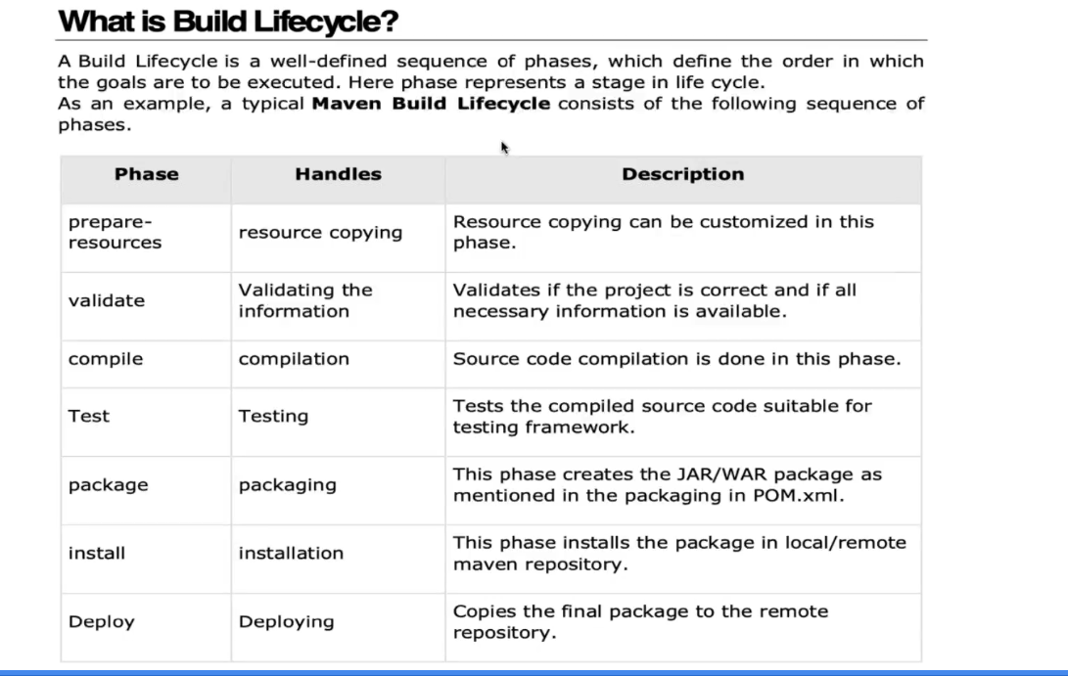

**Dependencies are Maven artifacts/components or libraries required in the class path during the Maven build. Example groupID, artifactID, version**

**Also, dependencies are java libraries needed for the project**

**Jar is the default file for maven and does not need to be mentioned in the pom.xlm file but war, ear and any other file will be required to be mentioned.**

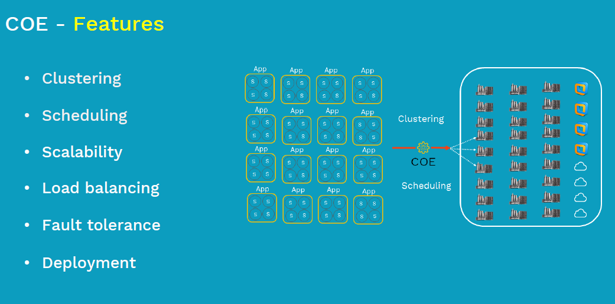

**KUBERNETES**

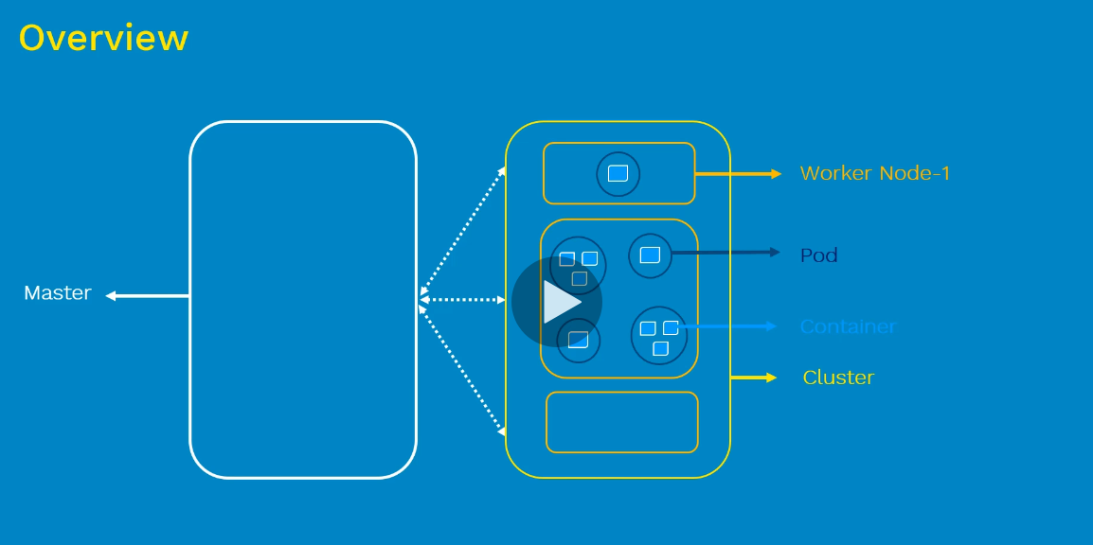 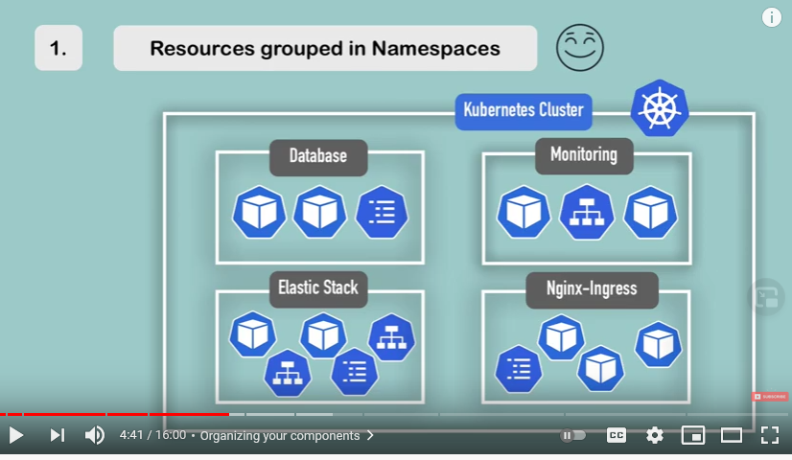

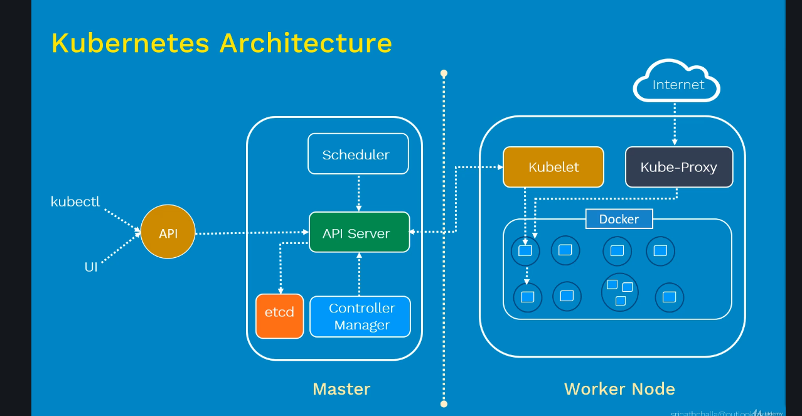

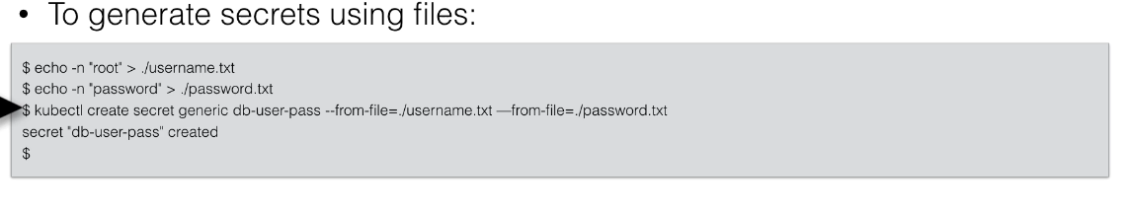

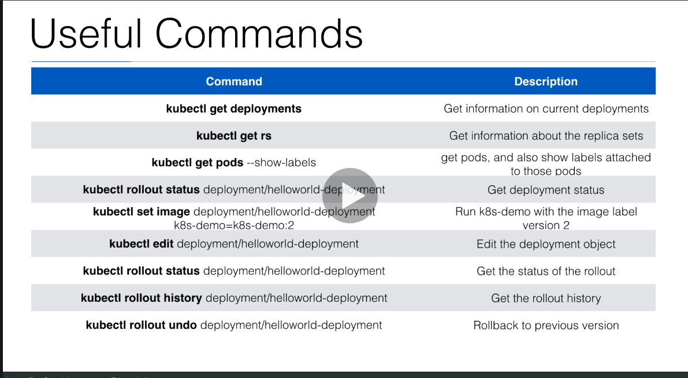

**StatefulSets**

StatefulSet is the workload API object used to manage stateful applications.

Manages the deployment and scaling of a set of [Pods](https://kubernetes.io/docs/concepts/workloads/pods/), *and provides guarantees about the ordering and uniqueness* of these Pods.

**The Kubernetes zero downtime is when a new deployment for example is apply the old deployment will still be applies until the new deployment is up and running that it will be replaced with zero downtime**

**With this strategy one pod will go down one pod will go up and so for**

kubectl describe pods my-pod can also help to see all activities inside the pod and also container that have failed.

**Kubernetes monitoring tools**

### Fluentd

### ELK Stack

EFK

### Google Stackdriver

Logfile will be written and store under the node at **/var/log/containers**

By default in Kubernetes, Docker is configured to write a container's stdout and stderr to a file under **/var/log/containers** on the host system.

Type of service : *ClusterIP NodePort LoadBalancer ExternalName*

**Type of service**

**clusterIP to connect frond end and backend pod**

**NodePort to expose front-end to external world**

**LoadBlancer to connect multiple pod together**

**Ingress connect cluster to external world**

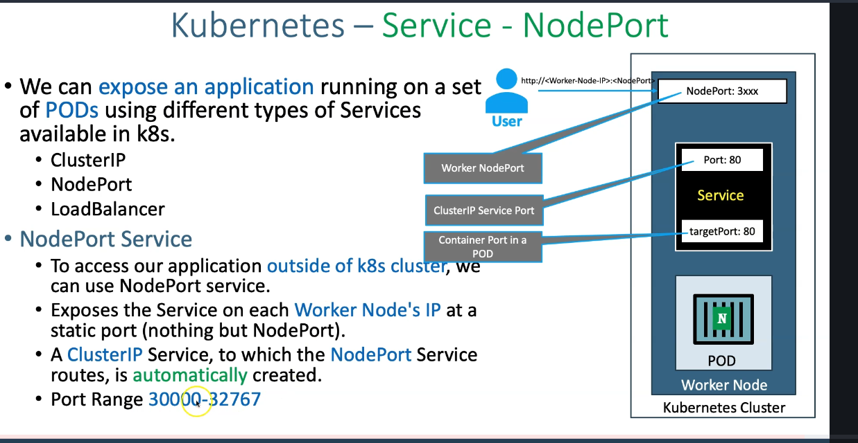

• **Ports**

* **port:** Port on which node port service listens in Kubernetes cluster internally
* **targetPort:** We define container port here on which our application is running.
* **NodePort:** Worker Node port on which we can access our application.

<https://kubernetes.io/docs/reference/kubectl/cheatsheet/>

**By default target port and port is 80 but if chosen to use different port (ex 81) the target pod need to be specify of the svc will fail**

**Kubenetes type volume**

1. **Emptydir this volume is create when the pod is launch and die when the pod die**
2. **Hostpath this create when the node is create and does not die**
3. **Persistan volume**

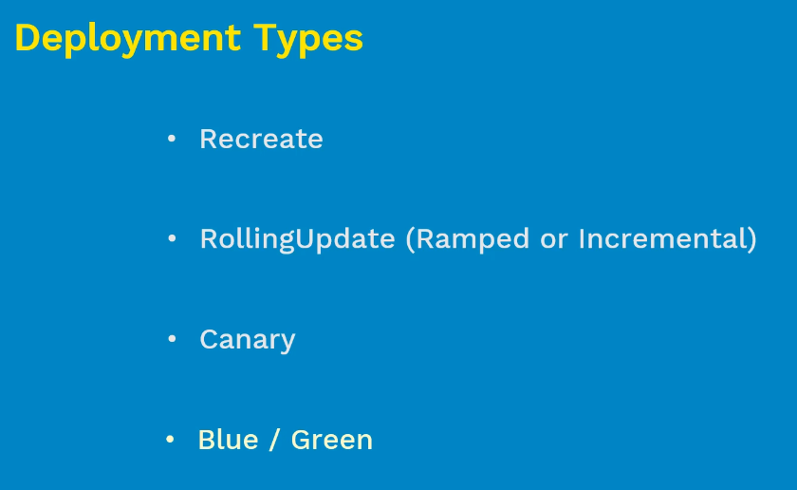

* [recreate](https://blog.container-solutions.com/kubernetes-deployment-strategies#kubernetes-recreate): terminate the old version and release the new one
* [ramped](https://blog.container-solutions.com/kubernetes-deployment-strategies#kubernetes-ramped) or rollingUpdate : release a new version on a rolling update fashion, one after the other
* 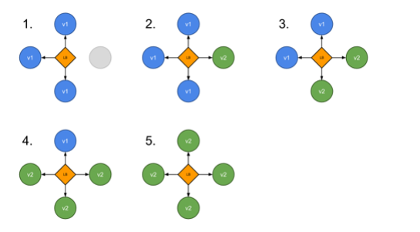
* [blue/green](https://blog.container-solutions.com/kubernetes-deployment-strategies#kubernetes-blue-green): release a new version alongside the old version then switch traffic

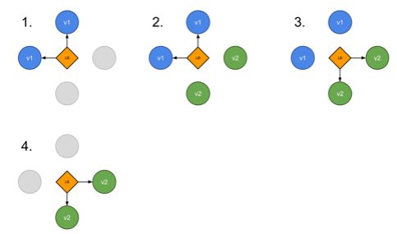

* [canary](https://blog.container-solutions.com/kubernetes-deployment-strategies#kubernetes-canary): release a new version to a subset of users, then proceed to a full rollout

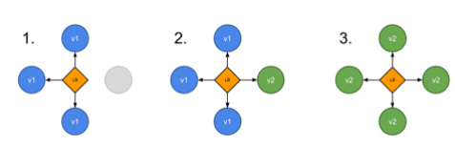

* [a/b testing](https://blog.container-solutions.com/kubernetes-deployment-strategies#kubernetes-a-b-testing): release a new version to a subset of users in a precise way (HTTP headers, cookie, weight, etc.). A/B testing is really a technique for making business decisions based on statistics but we will briefly describe the process. This doesn’t come out of the box with Kubernetes, it implies extra work to setup a more advanced infrastructure ([Istio](https://www.istio.io), [Linkerd](https://linkerd.io/), [Traefik](https://traefik.io/), custom nginx/haproxy, etc).

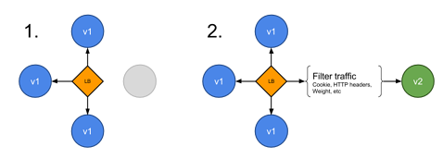

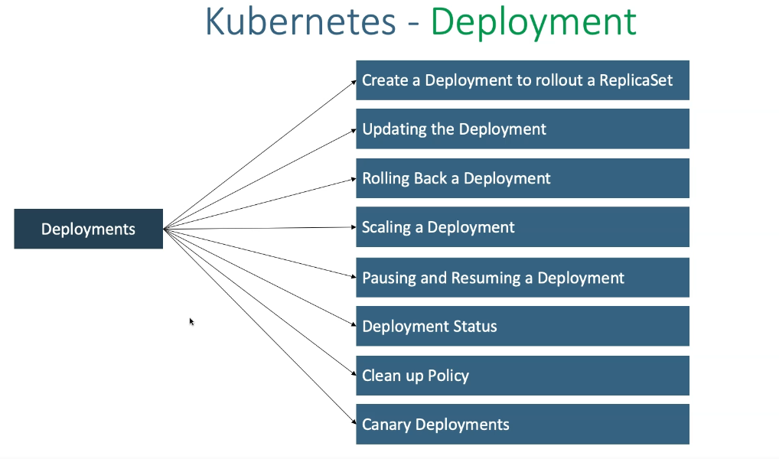

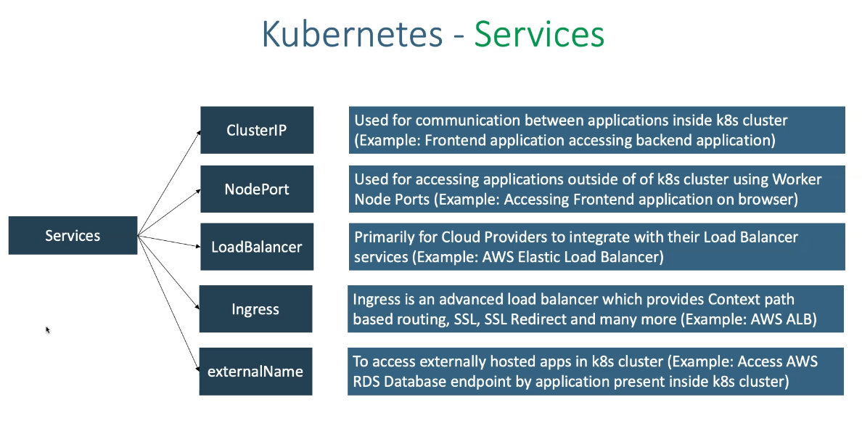

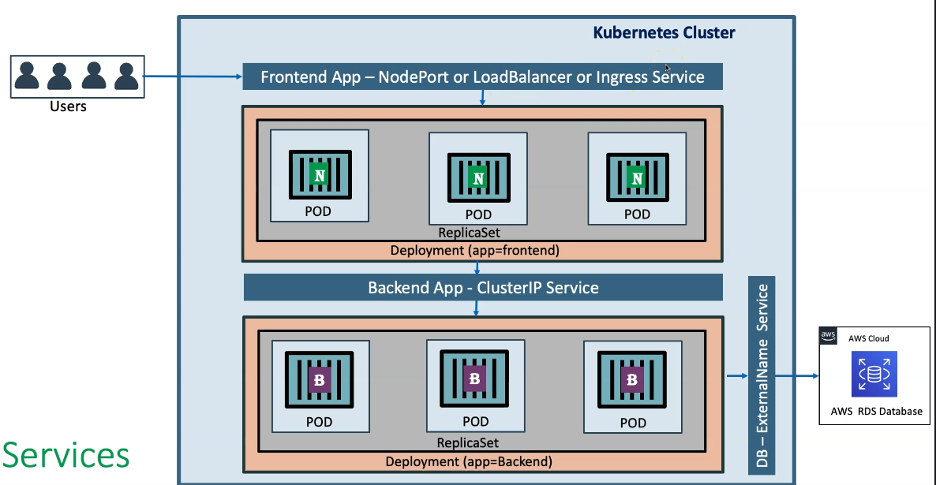

Kubernetes uses **liveness probes** to know when to restart a container

Kubernetes uses **readiness probes** to decide when the container is available for accepting traffic.

# Namespaces Walkthrough

Kubernetes [namespaces](https://kubernetes.io/docs/concepts/overview/working-with-objects/namespaces) help different projects, teams, or customers to share a Kubernetes cluster.

It does this by providing the following:

1. A scope for [Names](https://kubernetes.io/docs/concepts/overview/working-with-objects/names/).
2. A mechanism to attach authorization and policy to a subsection of the cluster.

Use of multiple namespaces is optional.

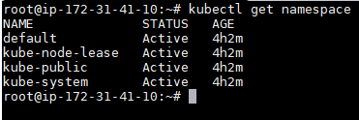 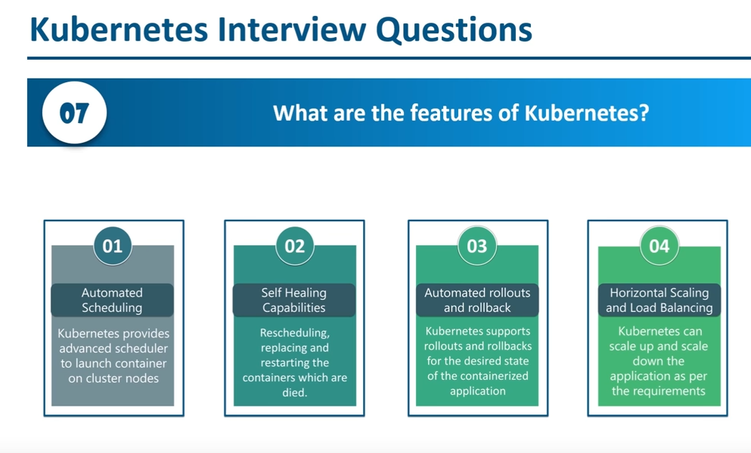

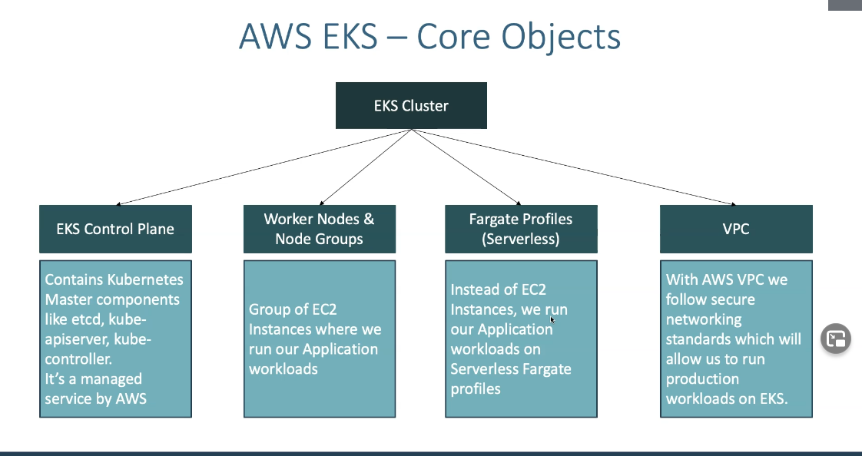

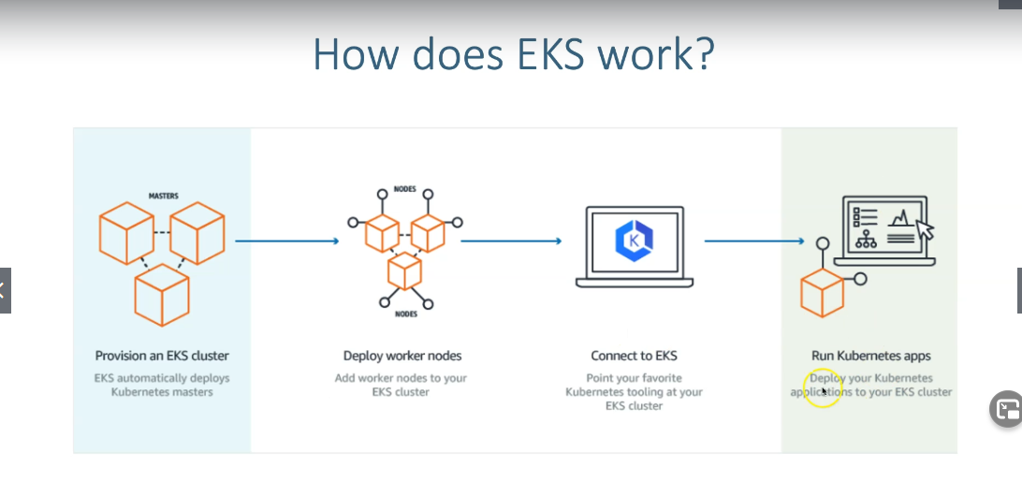

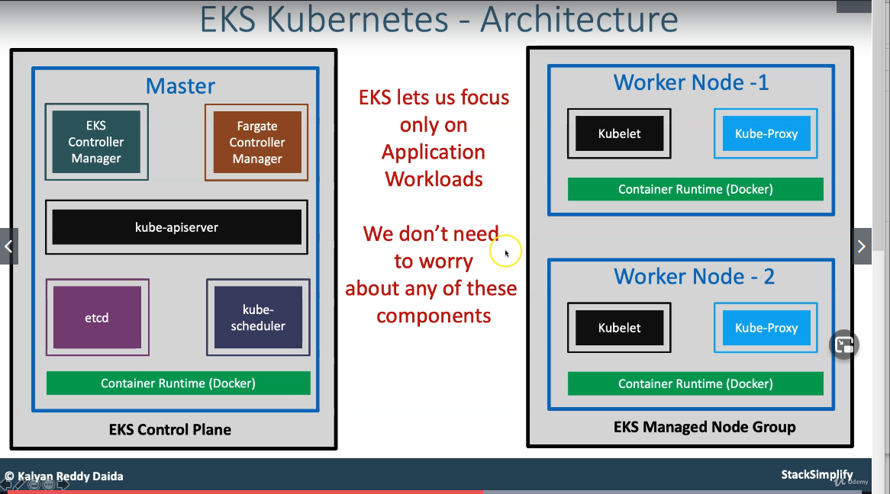

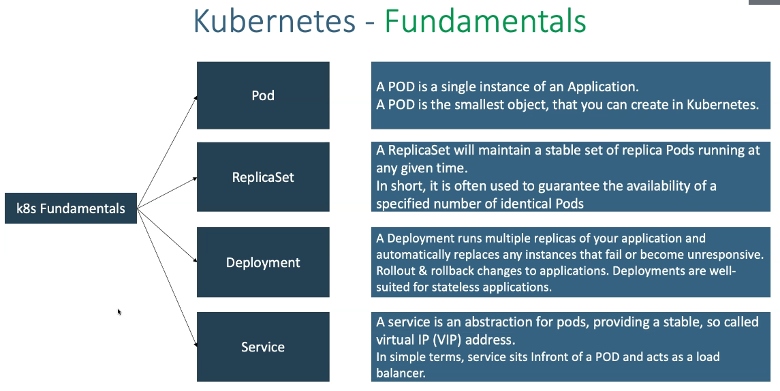

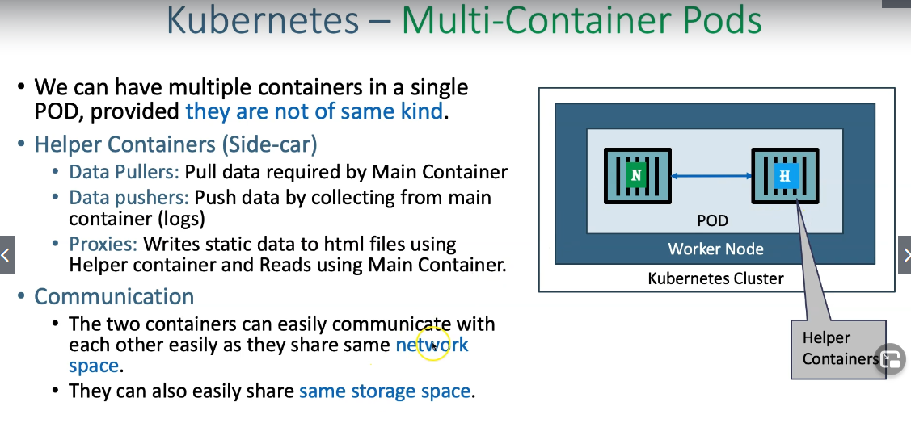 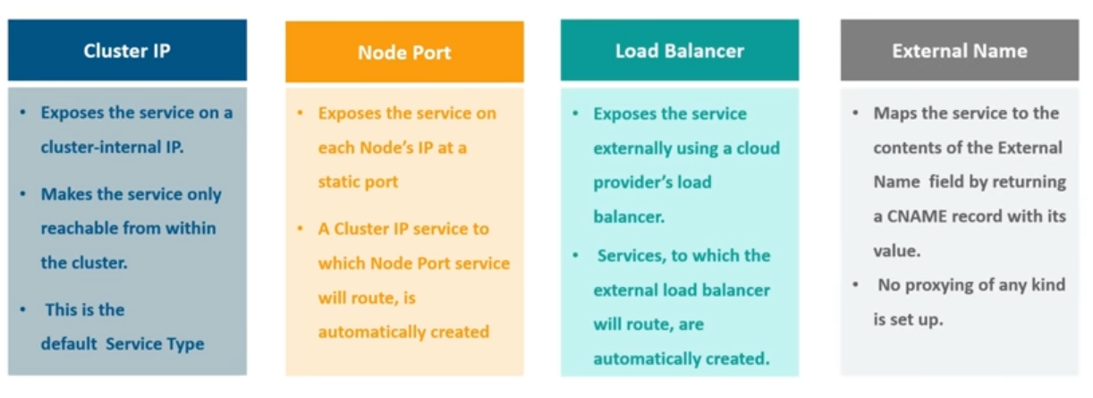 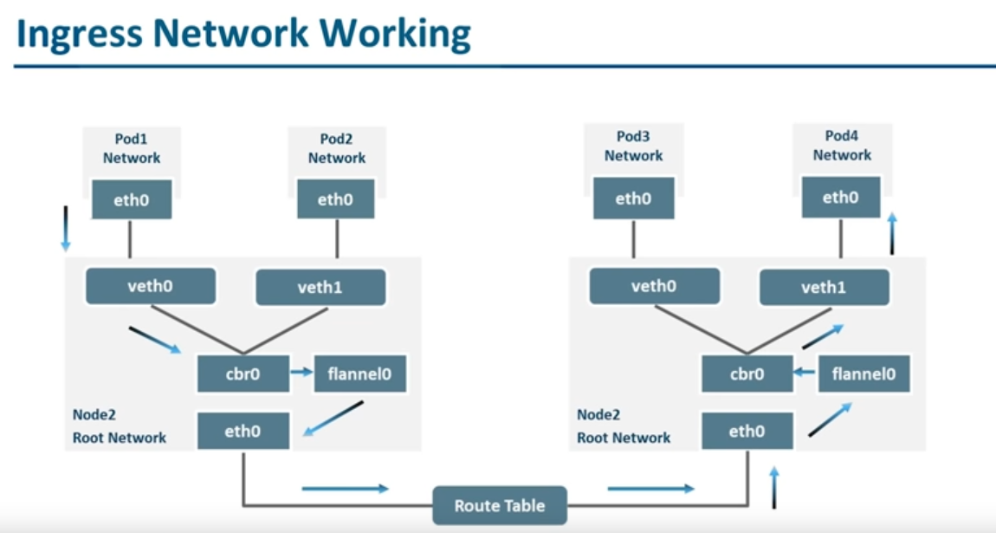

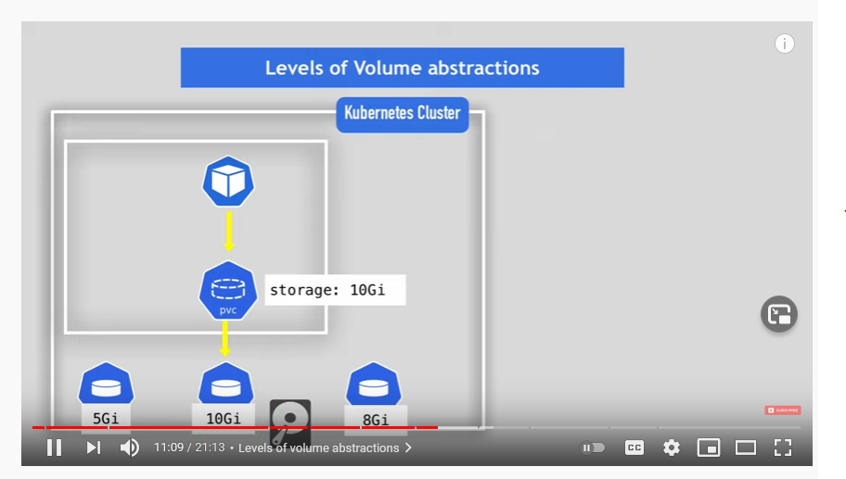

**RoleBinding and ClusterRoleBinding**

A role binding grants the permissions defined in a role to a user or set of users. It holds a list of *subjects* (users, groups, or service accounts), and a reference to the role being granted. A RoleBinding grants permissions within a specific namespace whereas a ClusterRoleBinding grants that access cluster-wide.

A RoleBinding may reference any Role in the same namespace. Alternatively, a RoleBinding can reference a ClusterRole and bind that ClusterRole to the namespace of the RoleBinding. If you want to bind a ClusterRole to all the namespaces in your cluster, you use a ClusterRoleBinding.

The name of a RoleBinding or ClusterRoleBinding object must be a valid [path segment name](https://kubernetes.io/docs/concepts/overview/working-with-objects/names#path-segment-names).

**RoleBinding examples**

Here is an example of a RoleBinding that grants the "pod-reader" Role to the user "jane" within the "default" namespace. This allows "jane" to read pods in the "default" namespace.

A RoleBinding can also reference a ClusterRole to grant the permissions defined in that ClusterRole to resources inside the RoleBinding's namespace. This kind of reference lets you define a set of common roles across your cluster, then reuse them within multiple namespaces.

For instance, even though the following RoleBinding refers to a ClusterRole, "dave" (the subject, case sensitive) will only be able to read Secrets in the "development" namespace, because the RoleBinding's namespace (in its metadata) is "development".

**ClusterRoleBinding example**

To grant permissions across a whole cluster, you can use a ClusterRoleBinding. The following ClusterRoleBinding allows any user in the group "manager" to read secrets in any namespace.

**HELM**

https://jamesdefabia.github.io/docs/user-guide/kubectl/kubectl_config_view/

Kubectl create deploy my-nginx --image nginx **--dry-run -o yaml** > deployment.yml

* helm install
* helm upgrade
* helm lint to check issue
* helm template

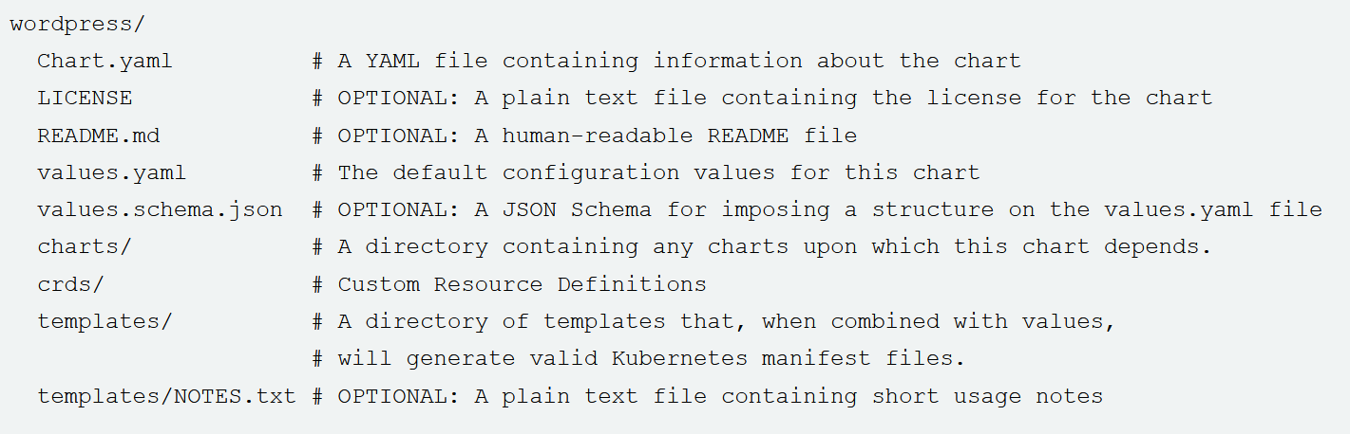

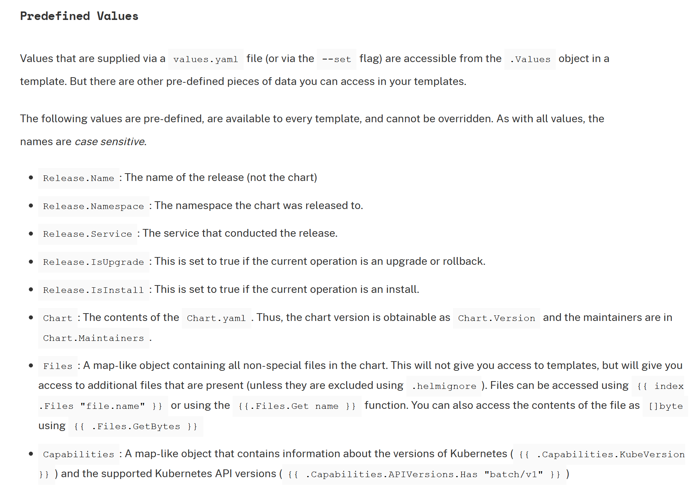

$ helm get manifest mydemo

**ARGOCD**

**ANSIBLE**

**Ansible Vault** is a feature of **ansible** that allows you to keep sensitive data such as passwords or keys in encrypted files, rather than as plaintext in playbooks or roles.

**Ansible Tower** is the easy-to-**use** UI and dashboard and REST API for **Ansible**.

$pscp to copy from local machine to unix machine

In ansible the copy module will **copy** the file from master to slave and the **fetch** module from slave to master

Ansible module:

Copy

Lineinfile

File

## Package management

## Service

Service

CLI_command

git

Package management

Fetch

Shell

Run

Command

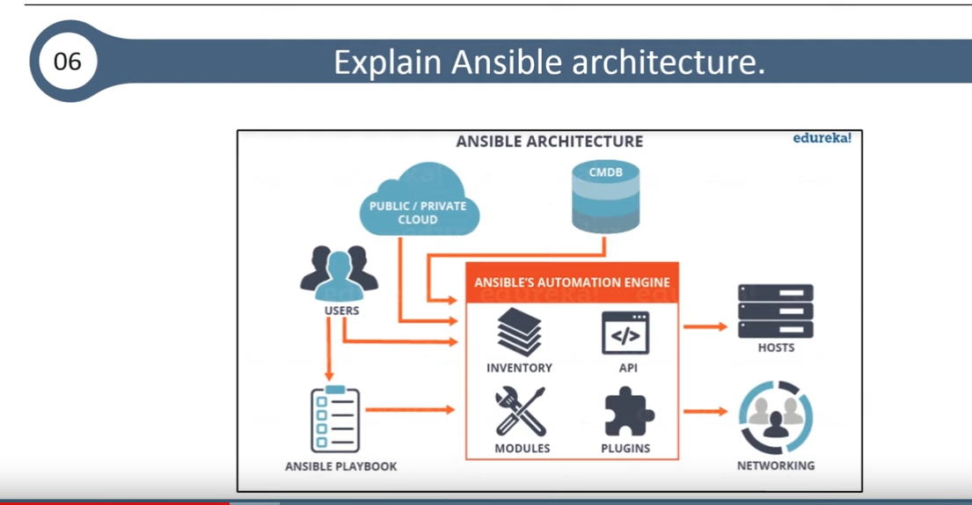

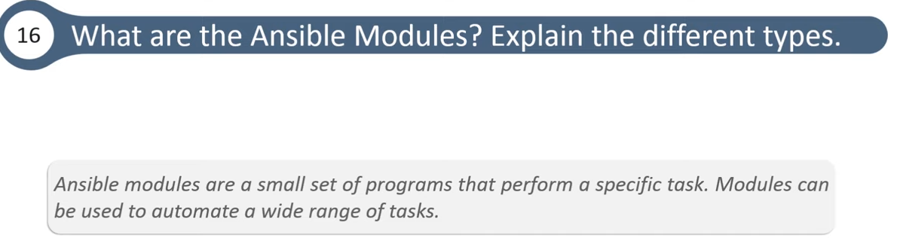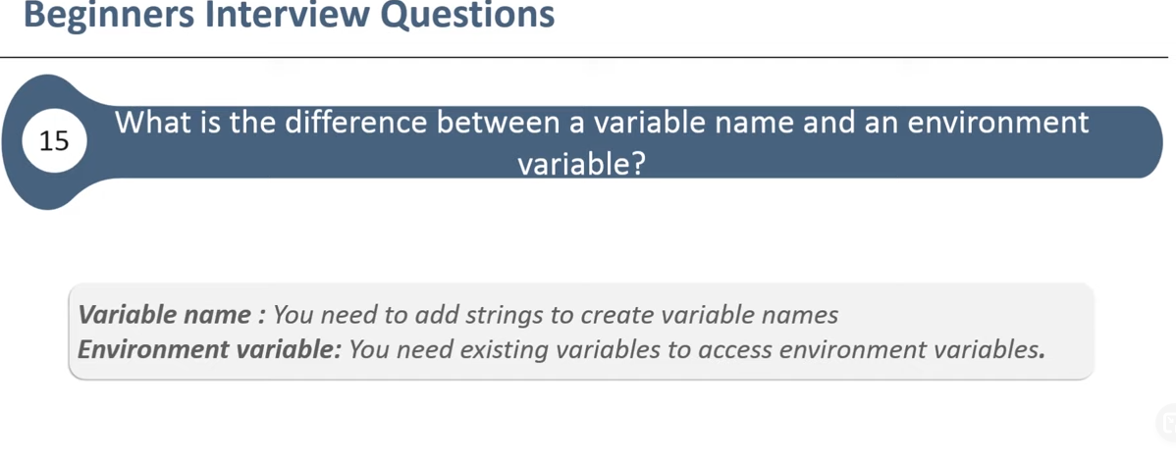



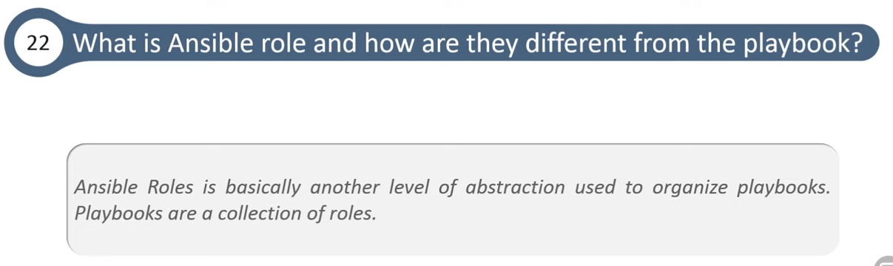

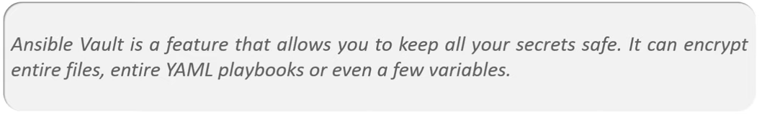

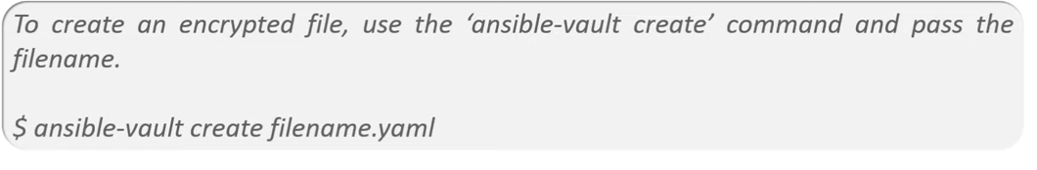

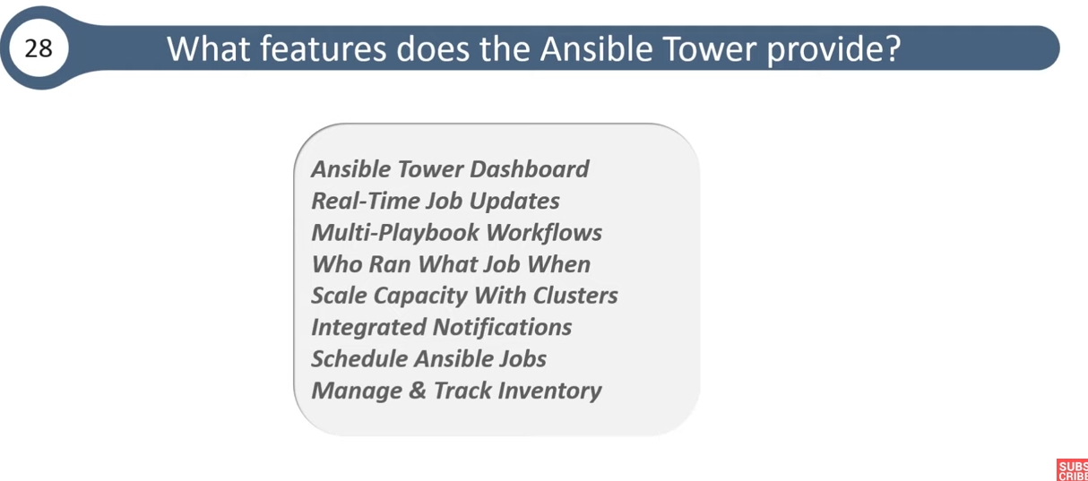

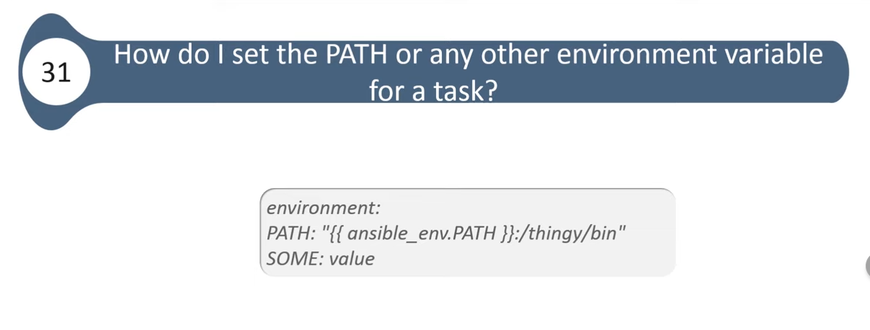

**A dynamic inventory or** plug-in is an executable file that Ansible uses to get the real-time hosts to file data especially for cloud server where the IP address change when the server is reboot

To install package or run a mode in ansible playbook base on distribution (OS) we use **the when clause**

---

- include_tasks: freebsd.yml

when: ansible_os_family == "FreeBSD"

tags:

- unbound

- include_tasks: debian.yml

when: ansible_os_family == "Debian"

tags:

- unbound

- include_tasks: redhat.yml

when: ansible_os_family == "RedHat"

tags:

- unbound

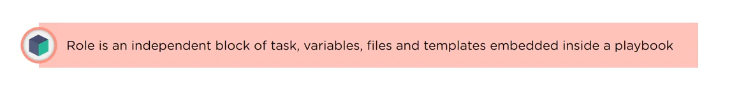

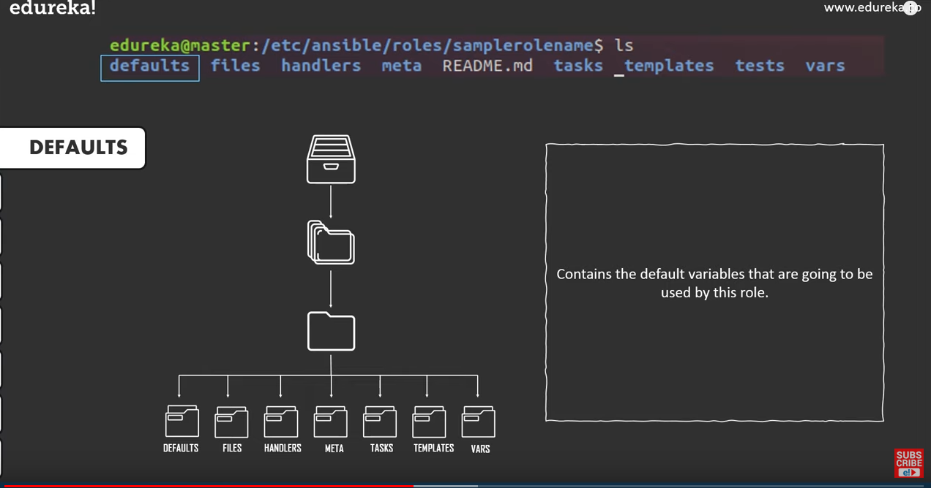

**What is Handlers in Ansible?**

Handlers are just like normal [tasks](https://docs.ansible.com/ansible/latest/user_guide/playbooks_intro.html#tasks-list) in an Ansible playbook but they run only when if the Task contains a “**notify**” directive. It also indicates that it changed something.

**How to run shell code on ansible**

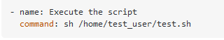

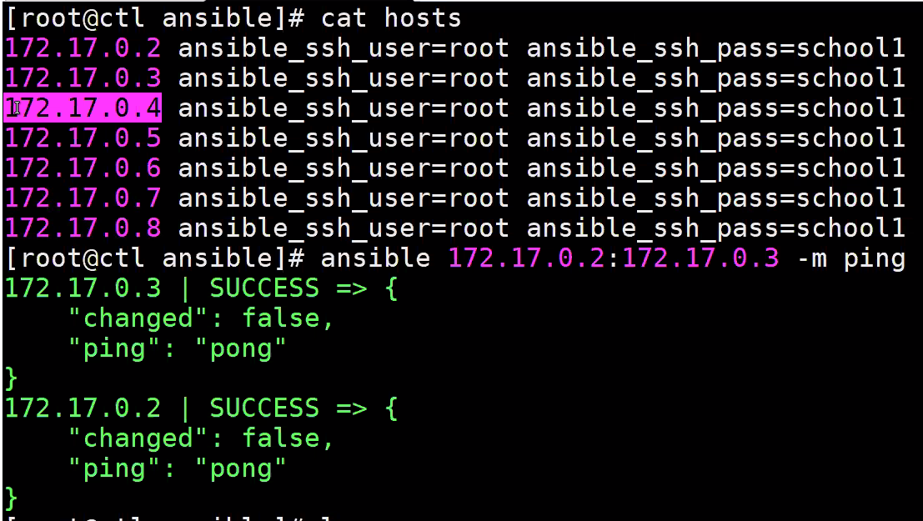

**DOCKER**

COPY and ADD are both Dockerfile instructions that serve similar purposes. They let you copy files from a specific location into a Docker image.

COPY takes in a src and destination. It only lets you copy in a local file or directory from your host (the machine building the Docker image) into the Docker image itself.

ADD lets you do that too, but it also supports 2 other sources. First, you can use a URL instead of a local file / directory. Secondly, you can extract a tar file from the source directly into the destination.

$ docker container prune will remove all stop container.

$docker images prune will remove all images.

$Docker inspect containerID to see all the change that happened inside the container.

**The difference between docker stop and docker kill** is that docker stop will send a kill -15 command to the container and wait still the container finish it process before it stops it on the other hand docker kill will send a kill -9 signal to terminate right away all processes and stop the container it is way faster.

When multiple CMD command are on the same file only the last one will take into consideration.

When **ONBUILD** is use in a dockerfile the instruction under it will not be applied for the current image but will be applied to new image when we use the current image as a base image

The **STOPSIGNAL** instruction sets the system call signal that will be sent to the container to exit. This signal can be a valid unsigned number that matches a position in the kernel’s syscall table, for instance 9, or a signal name in the format SIGNAME, for instance SIGKILL.

**The docker .ignore file** is a tool that is use to set rule and exemption for build context for example we can specify in that file to ignore file that are not relevant to the build and by doing so we save lot of time

Docker ignore file allow use to ignore process that are not part of the build process it helps us speed up the build process.

The **ARG** instruction defines a variable that users can pass at build-time to the builder with the docker build command using the --build-arg <varname>=<value> flag. If a user specifies a build argument that was not defined in the Dockerfile, the build outputs a warning. This will be useful to build dockerfile with multiple OS (FROM) and the user will just pas the argument to select their OS choice

ARG my_arg

FROM centos:7 AS base

RUN echo "do stuff with the centos image"

FROM base AS branch-version-1

RUN echo "this is the stage that sets VAR=TRUE"

ENV VAR=TRUE

FROM base AS branch-version-2

RUN echo "this is the stage that sets VAR=FALSE"

ENV VAR=FALSE

FROM branch-version-${my_arg} AS final

RUN echo "VAR is equal to ${VAR}"

## Use multi-stage builds

With multi-stage builds, you use multiple FROM statements in your Dockerfile. Each FROM instruction can use a different base, and each of them begins a new stage of the build. You can selectively copy artifacts from one stage to another, leaving behind everything you don’t want in the final image.

**How to build secure containers:**

1. Verify authenticity of any software on the image.
2. Regular scan of the image using docker bench or open scap
3. Host server of the registry were the image is located is secured
4. If taking file from internet, make sure those files are signed or valid checksums
5. If adding a file remotely make sure the url is **https** and not http
6. Always include the right GPG Keys before using the package manager to update packages.
7. Manage sensitive data with docker secret.
8. On the FROM directive of the docker file always use a specific tag like from ubuntu 18.04 and not from ubuntu
9. Never run the application as root
10. Drop privilege of the user inside the container ASAP
11. Use gosu
12. and not sudo
13. Use if possible minimum base image like alpine
14. Never run ssh inside a container
15. Always monitor the OS where container is running
16. Use monitoring tool

The **gosu** utility is often used in scripts called from ENTRYPOINT instructions inside Dockerfiles for official images. It's a very simple utility, similar to sudo, that runs a given instruction as a given user.

PMD

Bug detection

Selenium integrity and regretion test

Metric test

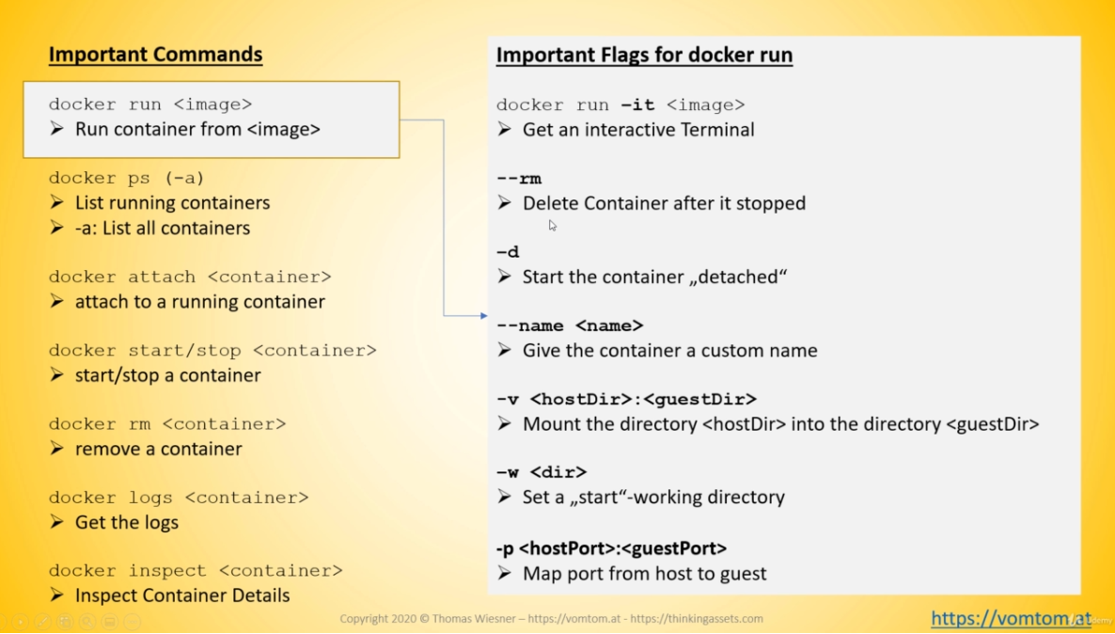





**JENKINS**



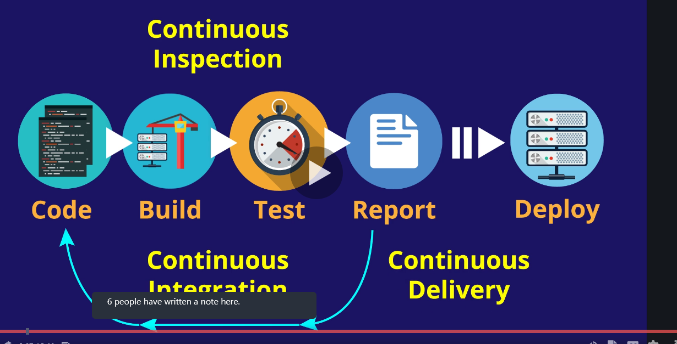

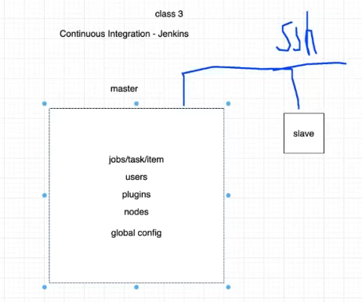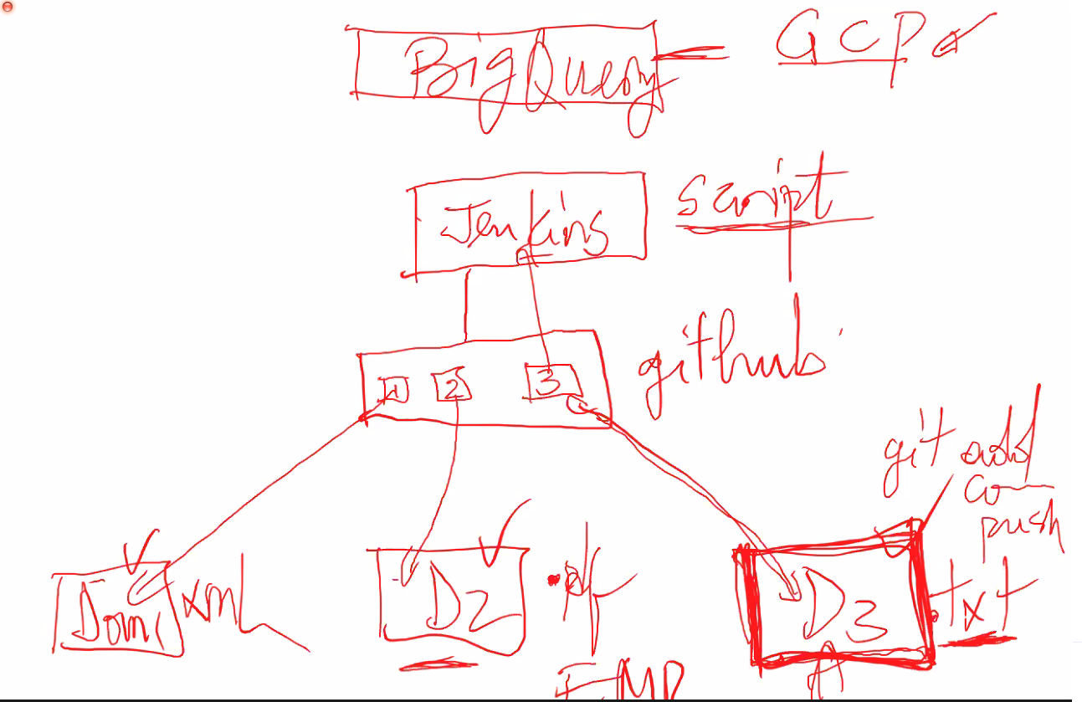

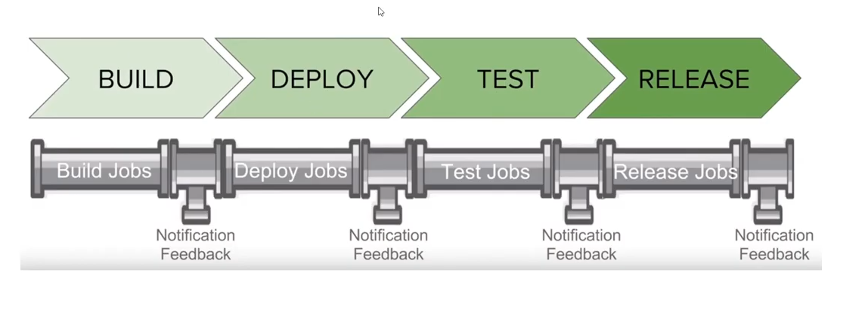

To make Jenkins job fail base on specific word set the **failFast** to true in the **jenkinsfile** and in the same file grep the word.

in jenkins we can select the number of built to be display by selecting discard old builds under the general section

**for active reactive parameterized job,** we can use groovy script and add active choice first the add reactive choice but we need to select this project is parameterized under general section

to copy job from one Jenkins to another to var/lib/Jenkins/jobs cd inside the jobs name and copy the **config.xml** file go the receiving Jenkins paste it on the **script console** and click on **load job from disk.**

we can use Groovy script on the console script to launch multiple job at once on Jenkins.

multibranch job are set in Jenkins from the Jenkinsfile and if for example the developer add a new branch it will get automatically trigger into Jenkins

**What is a Jenkins Shared Library?**

Jenkins Shared Libraries are written in [Groovy](https://groovy-lang.org/) and allow you to create common sets of logic, and share that among teams/projects/organizations. Instead of “copy and pasting” the code from some other Jenkinsfile, you can simply load a library into Jenkins and every pipeline job on that Jenkins master has access to that shared library

**Why you should be using Jenkins Shared Libraries in Your Pipelines**

Imagine that within your team you have three projects that all deploy code in the same way. You would not want to have to write that logic three different times. This is a violation of the DRY (Don’t repeat yourself) principal. This means that, if the process changes, then each team has to go and update their Jenkinsfile to accommodate the changes. This usually includes copying what someone else has done, and then pasting the code into their project and then making small tweaks to accommodate their project.

Scripting pipeline

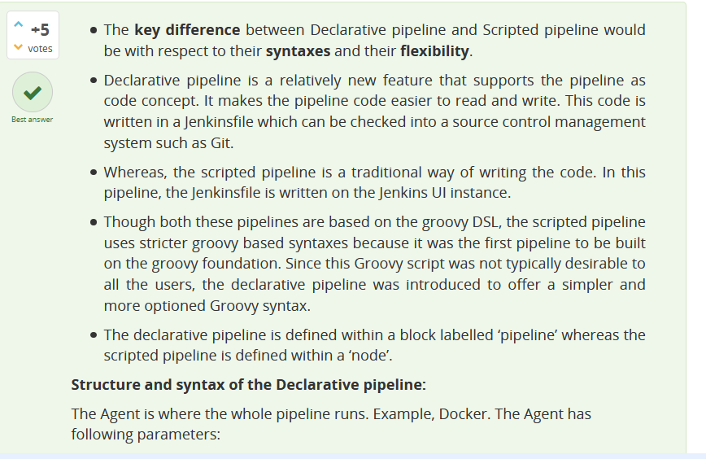

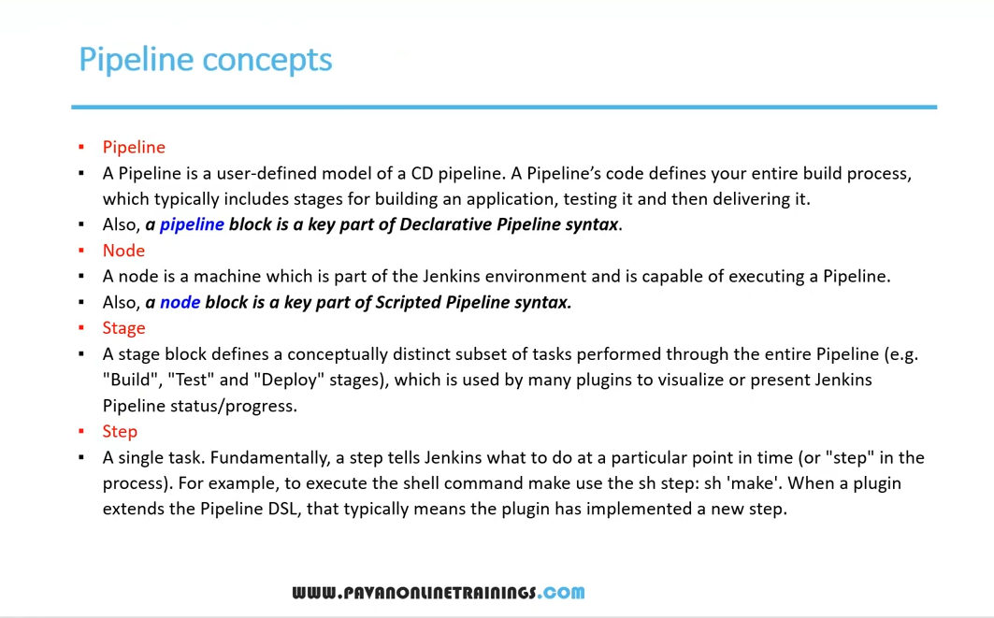

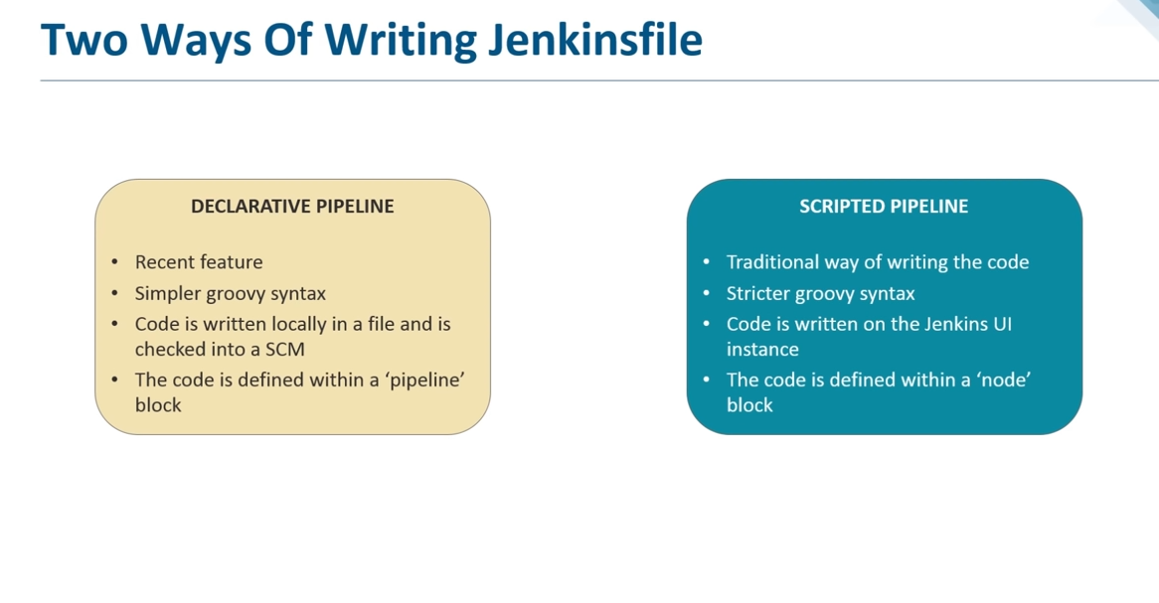

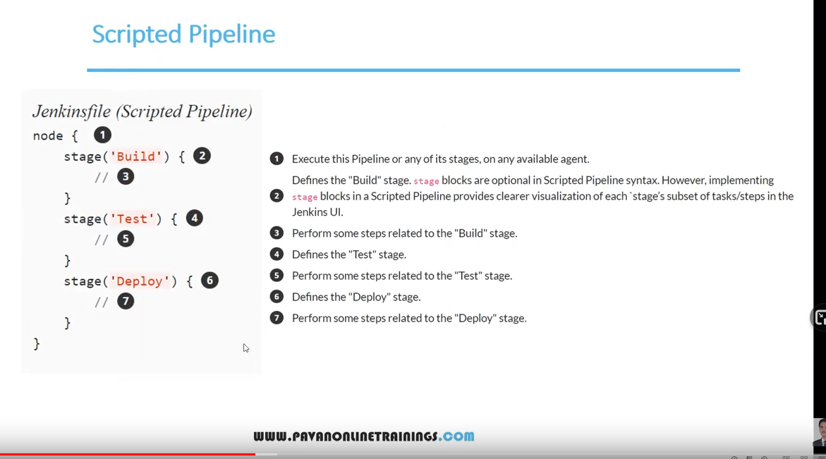

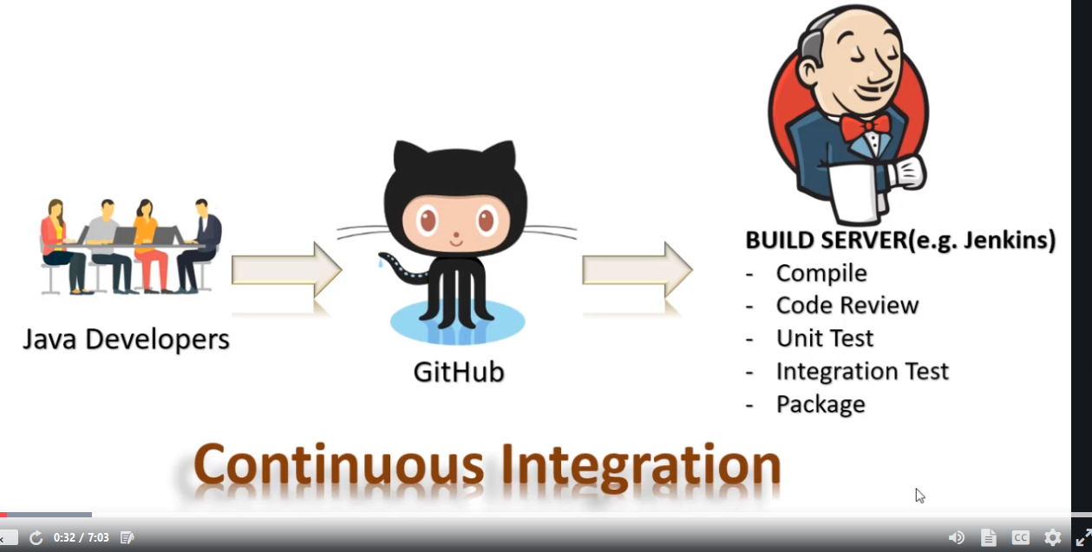

SHELL SCRIPTING

find /path/to/dest -type -f -empty -delete TO FIND EMPTY FILE

find /path/to/dest -type -d -empty -delete TO FIND EMPTY DIRECTORY

we can schedule automatic run of script using crontab command

to check how many time a word appear on a file cat /etc/passwd | grep -o systemd|wc -l

**AWS**

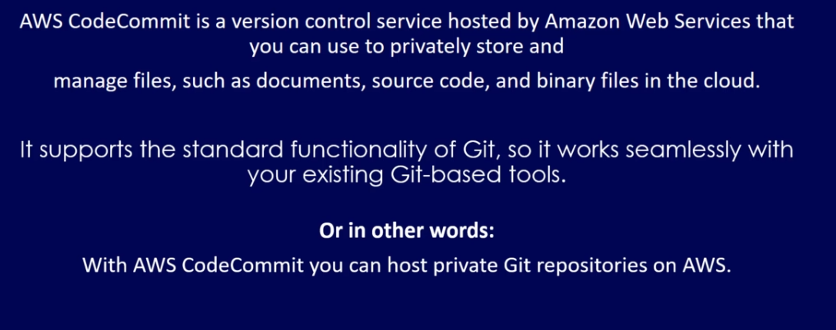

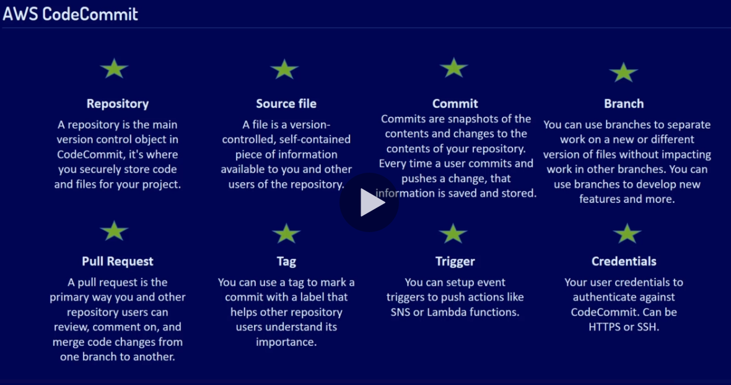

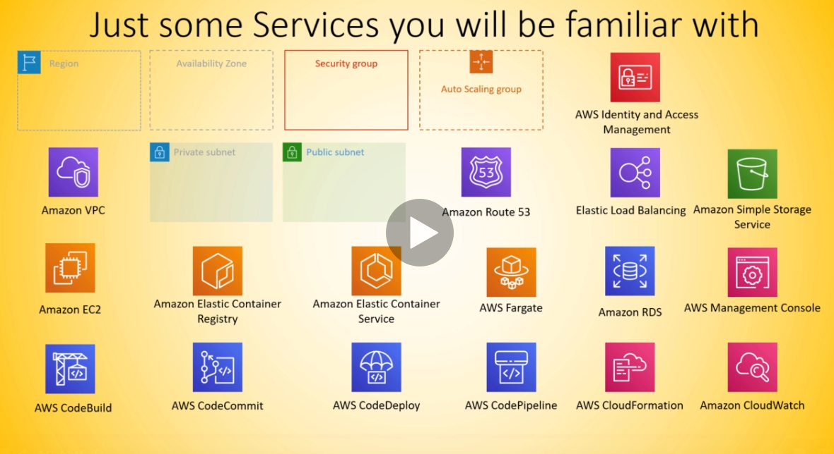

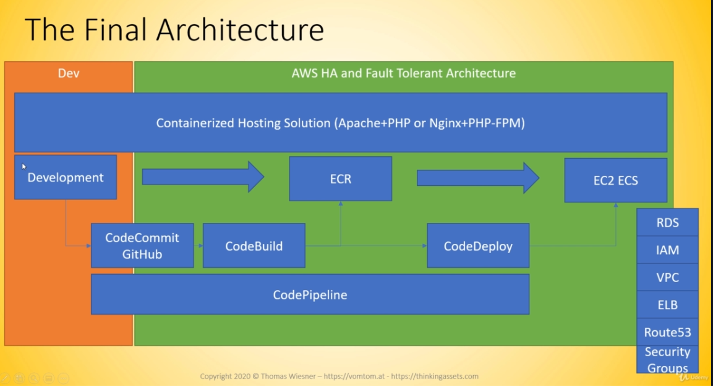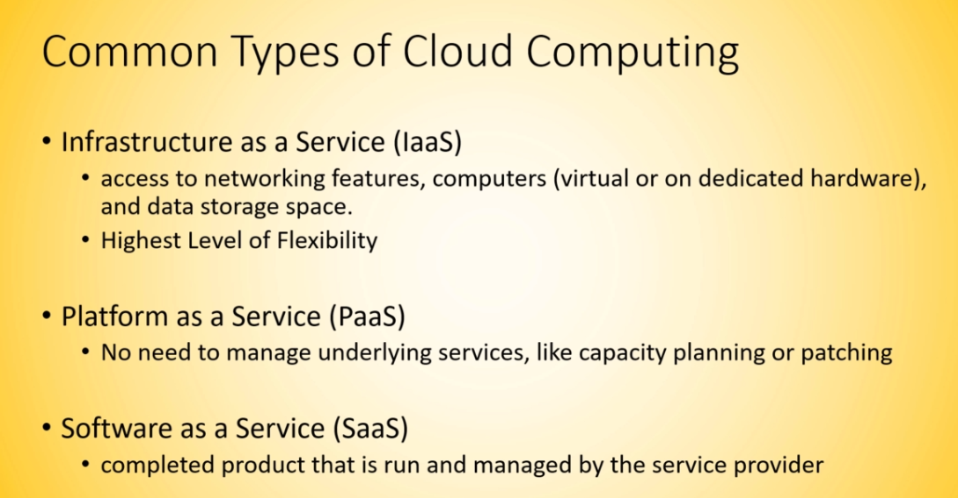

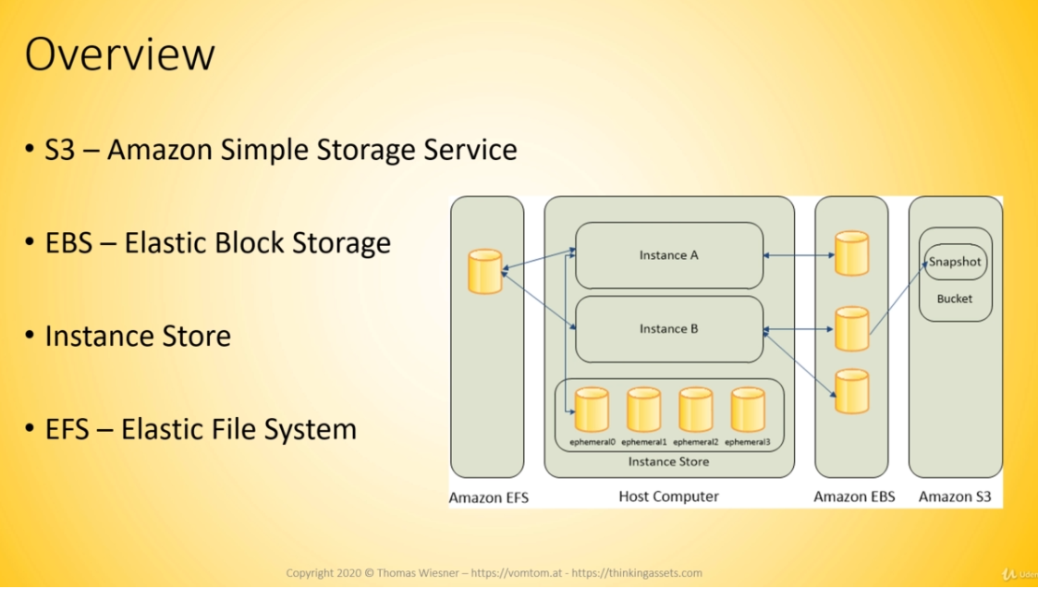

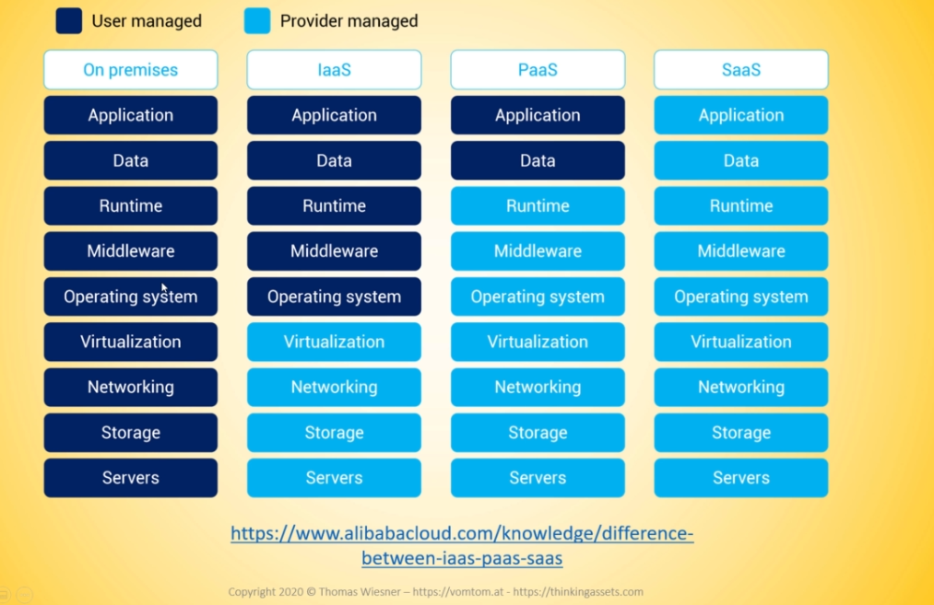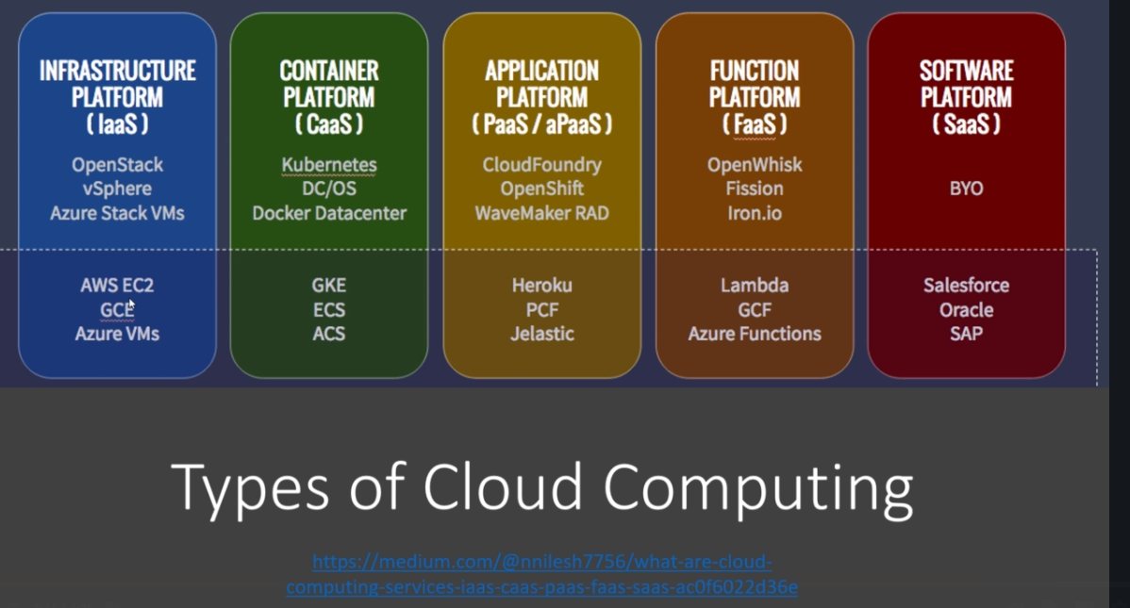

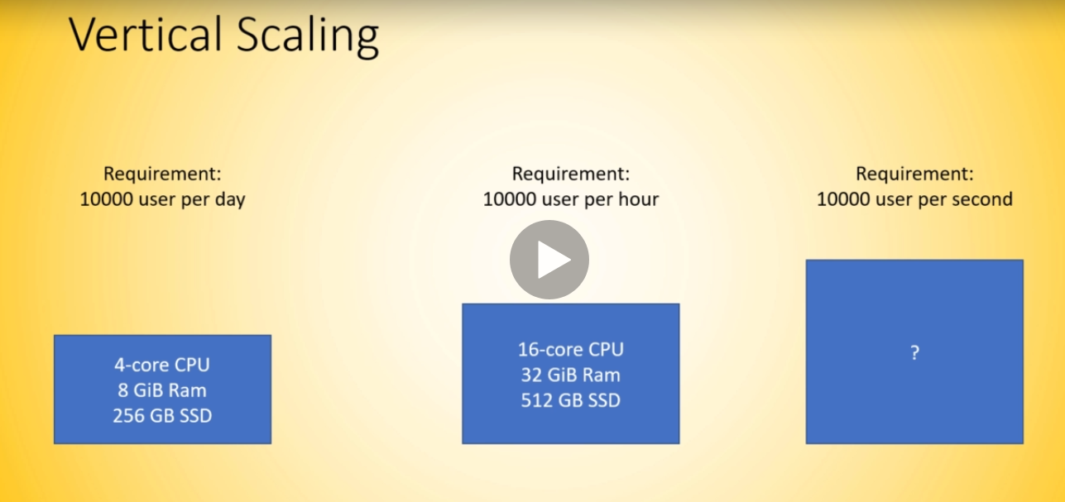

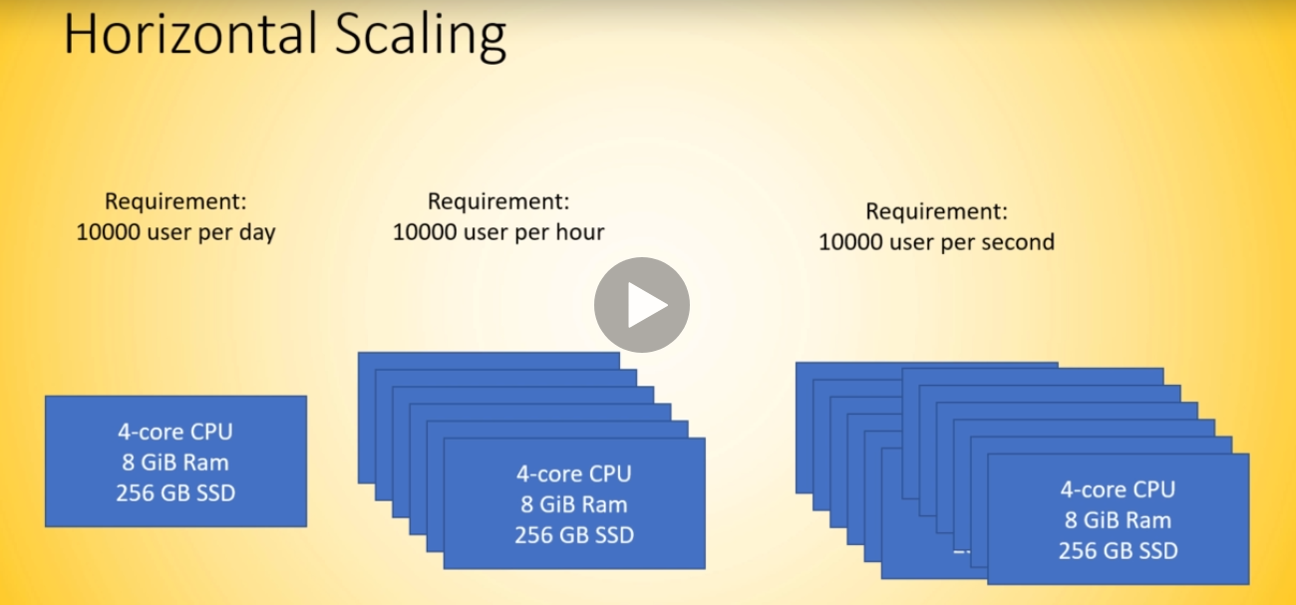

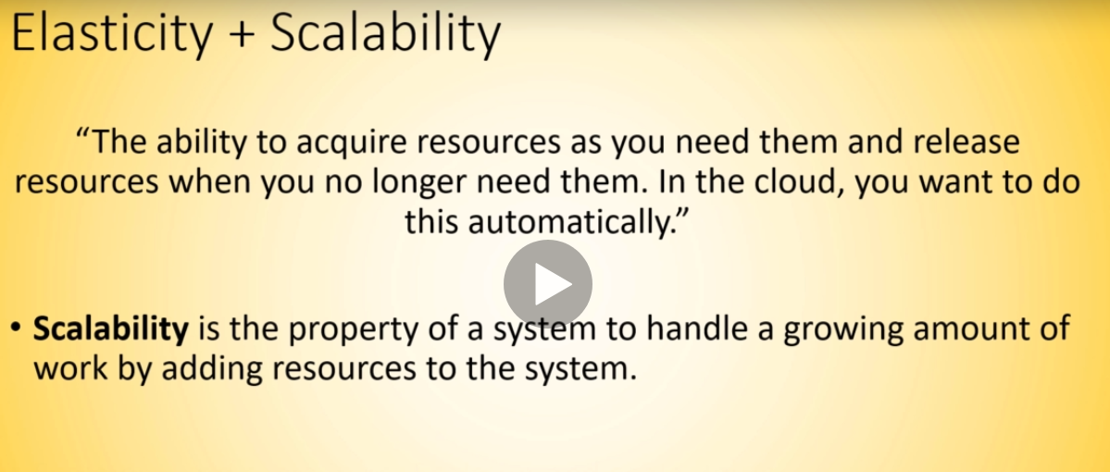

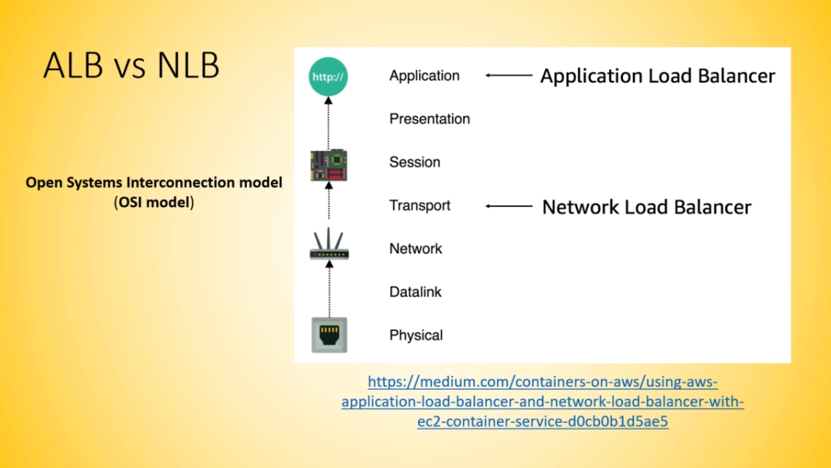

Path base routing when the LB select the target group according to the input of the user

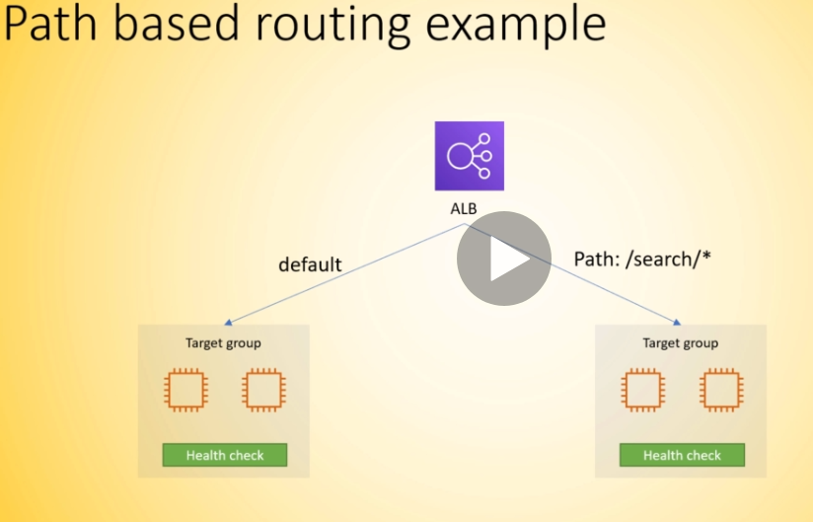

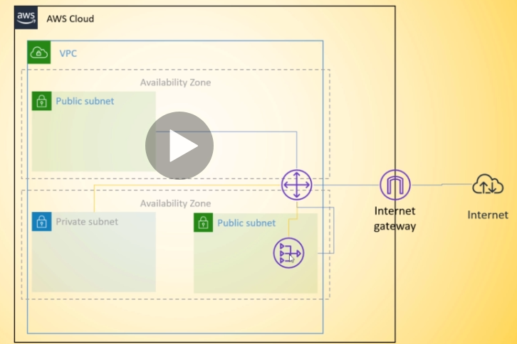

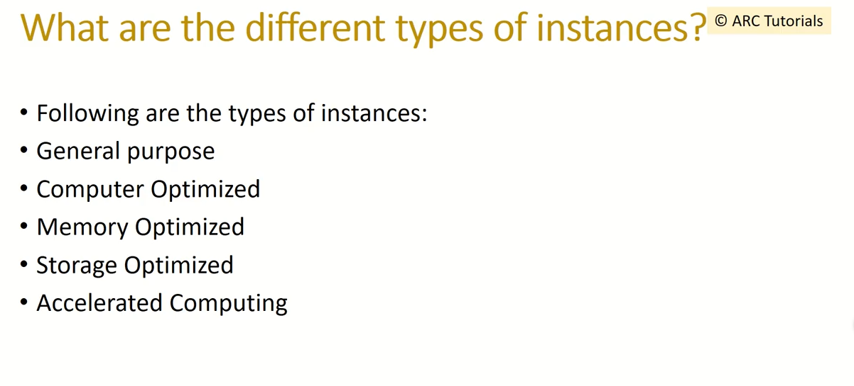

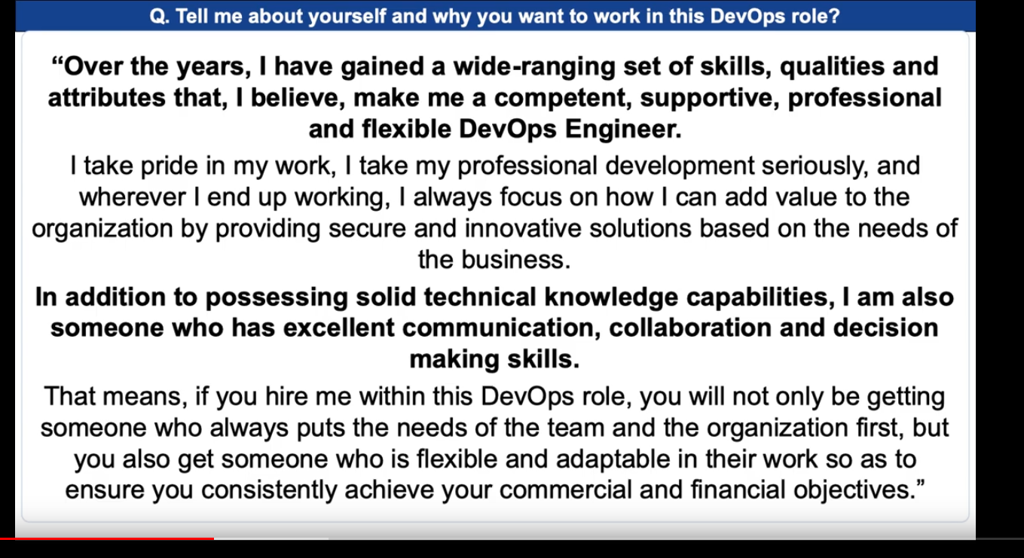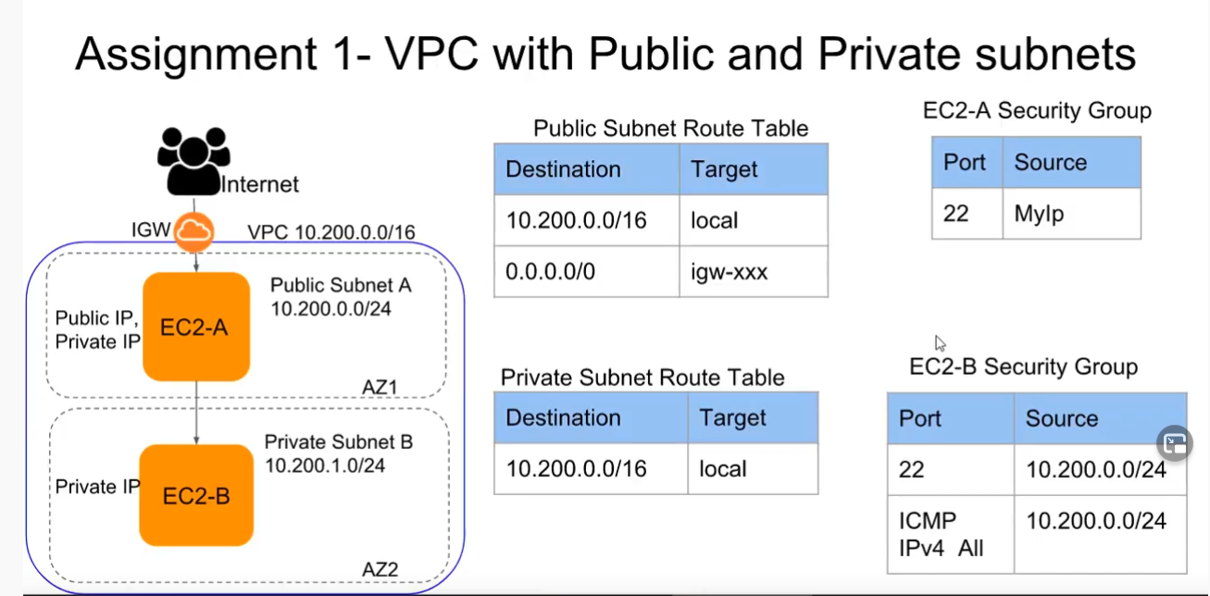

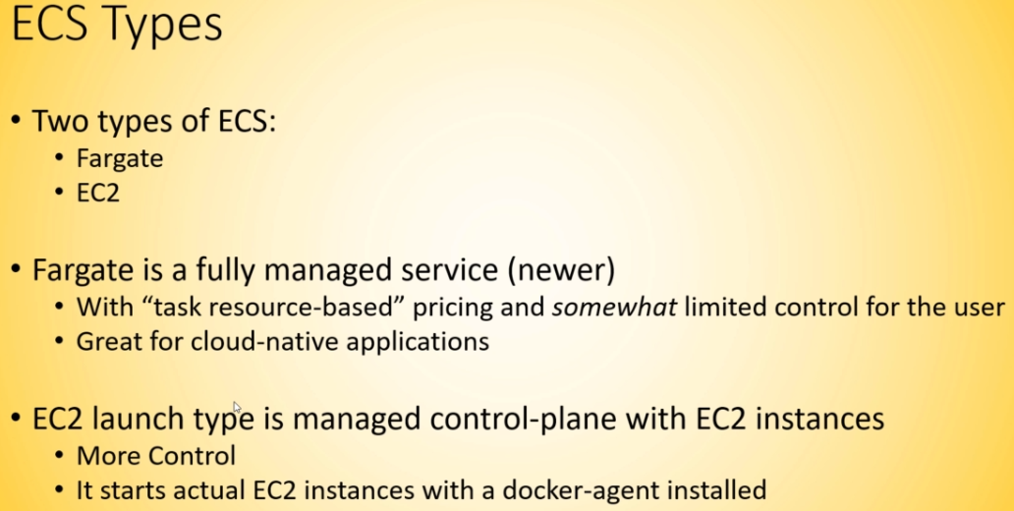

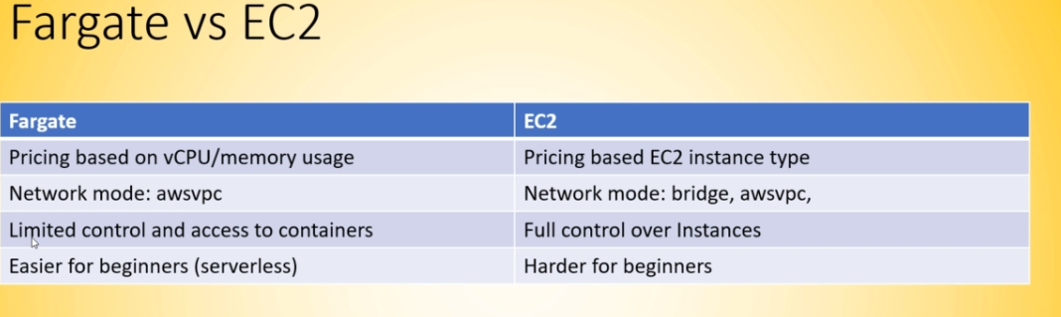

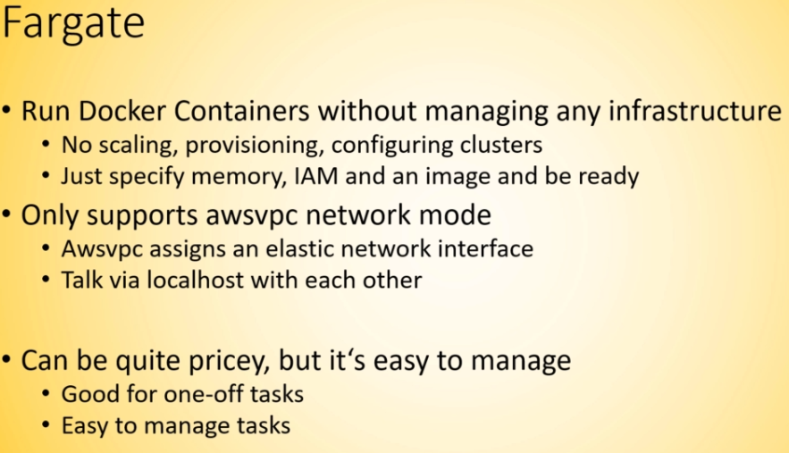

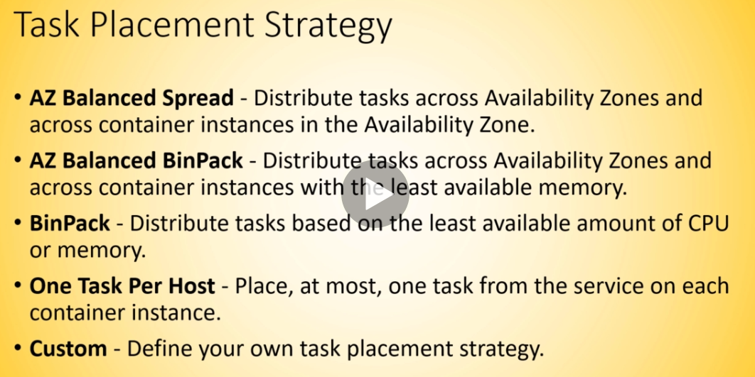

**What I have learned so far**

**EC2**

**ELB**  elastic load balancer

**ALB** application loadbalancer

**NLB** network load balancer

Auto scaling group to scale ec2 instance base on traffic or memory usage or cpu usage

**Keypair**

**Security group**

**EFS**  elastic file system that will be mount on ec2 instance

**S3**  bucket and how to manipulate then with awscli

**IAM**  to create user, role , group and add policy

**VPC**

To setup a VPC do the following

1. Create the VPC
2. Create the subnets (publics and private) and enable auto-generation of IP adrressv4
3. Create the Internet gateway
4. Create the NAT gateway if applicable
5. Create route table and add route
6. Associate subnet mask on the route table
7. Launch EC2 instances using VPC abd subnet credential don’t forget enable the auto ip.

For LoadBalancer always add the LB security group to the ec2 rules

**Codecommit** for version control equivalent of git

**ECR**  elastic container registry that act like dockerhub is use to store image in repository

**ECS**

\***Fargate** : create a Task Definition, cluster and add task definition then create a task,service in the cluster,add a Lb to the cluster

**\*EC2**

Service,task,capacity provider,launch configuration

**CLOUDFRONT** for edge location

**LAMBDA** for trigger

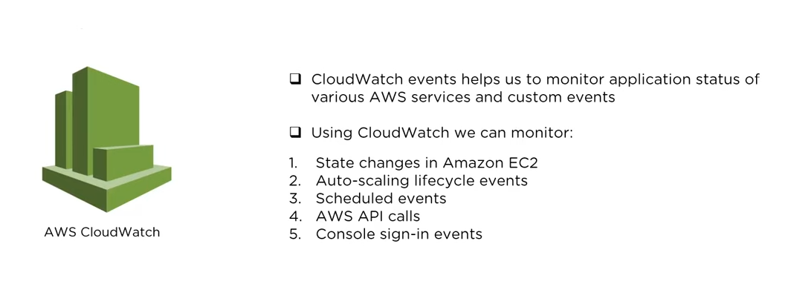

To get the public IP of an instance from the terminal **$sudo curl ifconfig.co**

**MYSQL**

<http://g2pc1.bu.edu/~qzpeng/manual/MySQL%20Commands.htm>

**MONITORING**

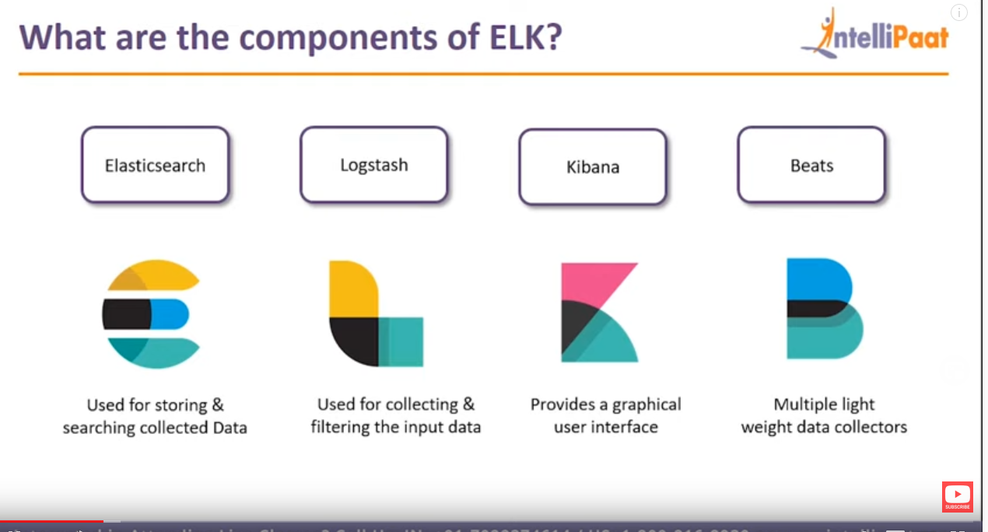

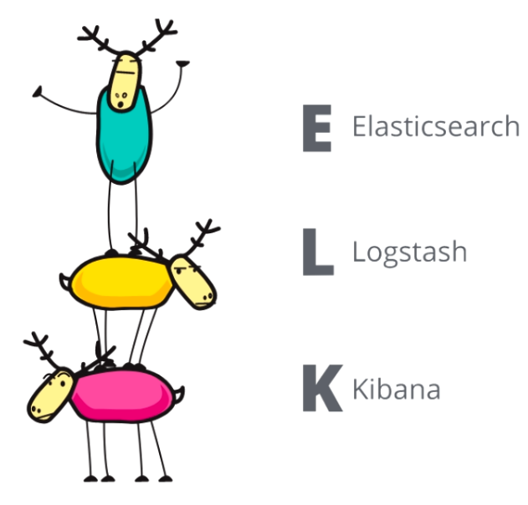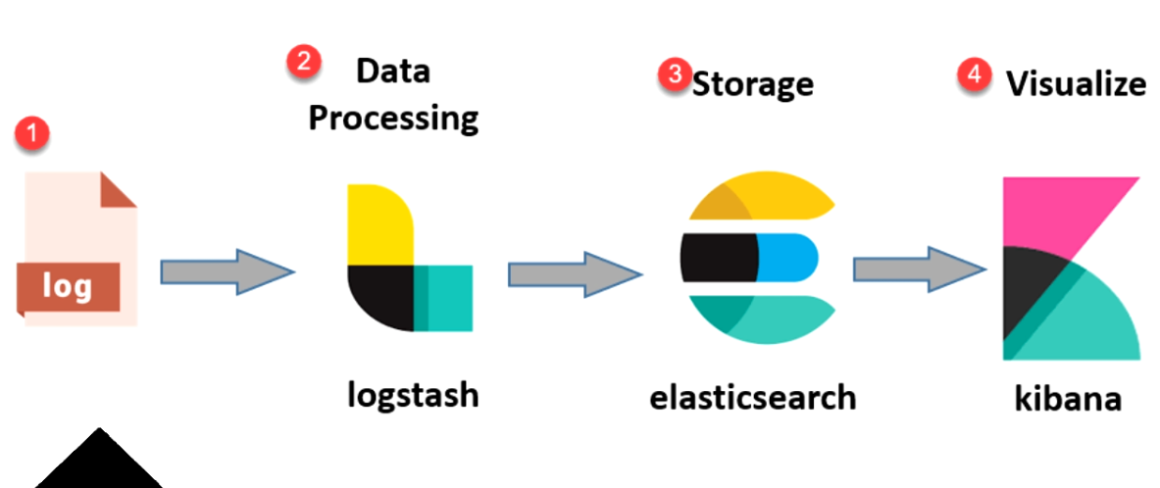

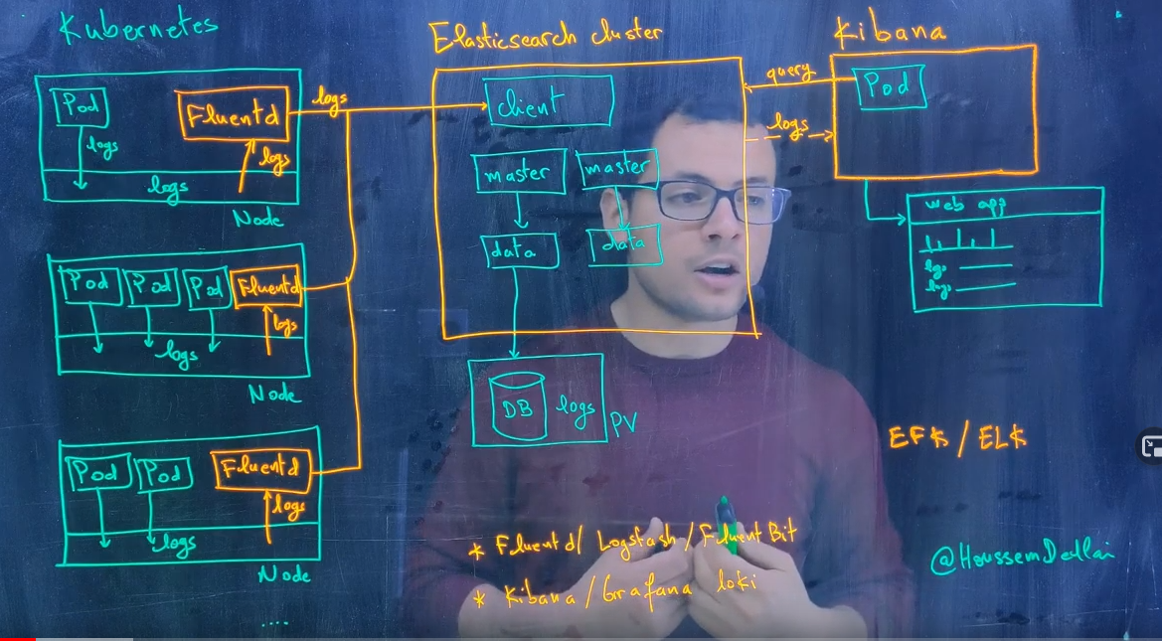

What is Filebeat and Metricbeat?

Developers describe **Filebeat** as "A lightweight shipper for forwarding and centralizing log data". It helps you keep the simple things simple by offering a lightweight way to forward and centralize logs and files. On the other hand, **Metricbeat** is detailed as "A Lightweight Shipper for Metrics".

**OTHERS**

A **distributed application** is an application comprised of multiple clients that communicate with servers or machines through a network. Example client-server architecture, broker pattern or service-oriented

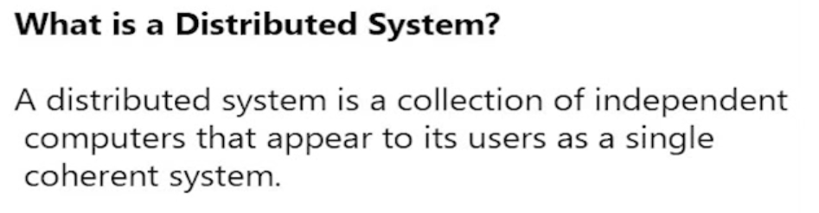

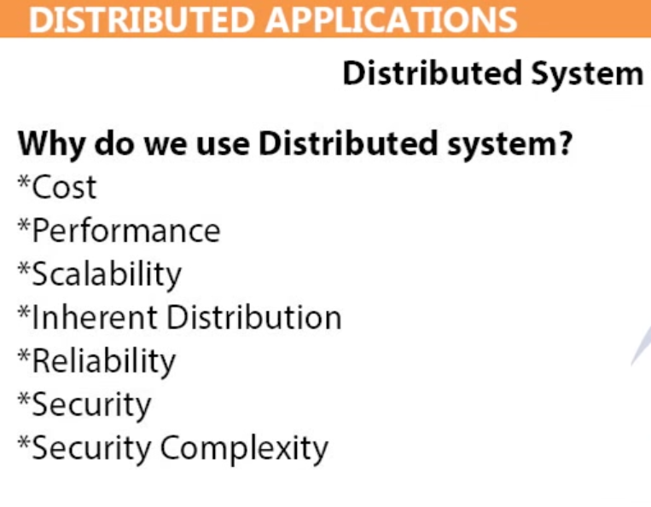

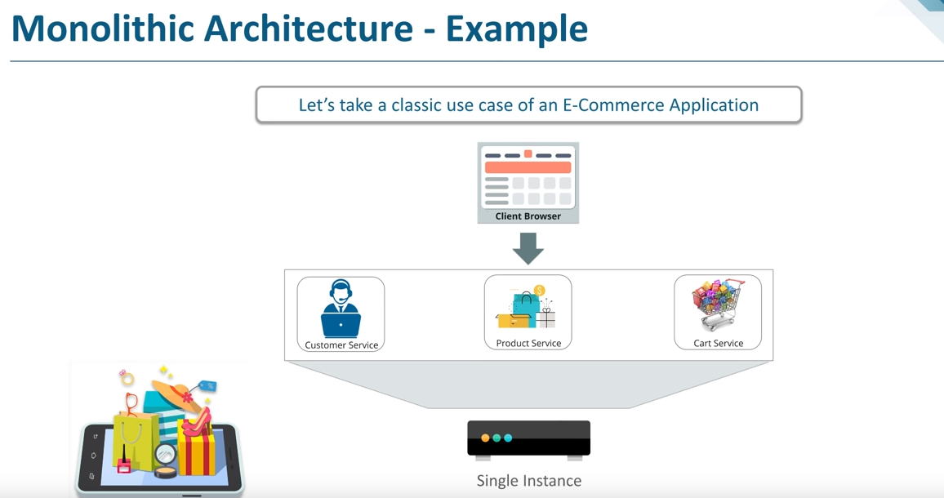

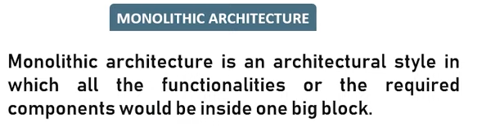

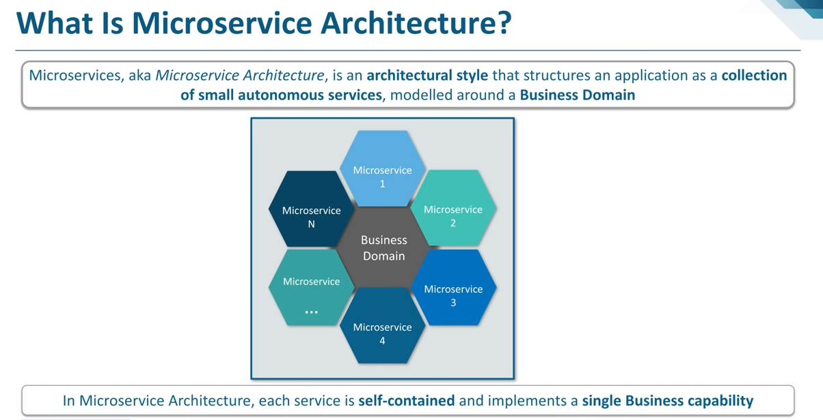

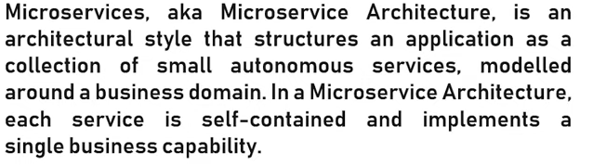

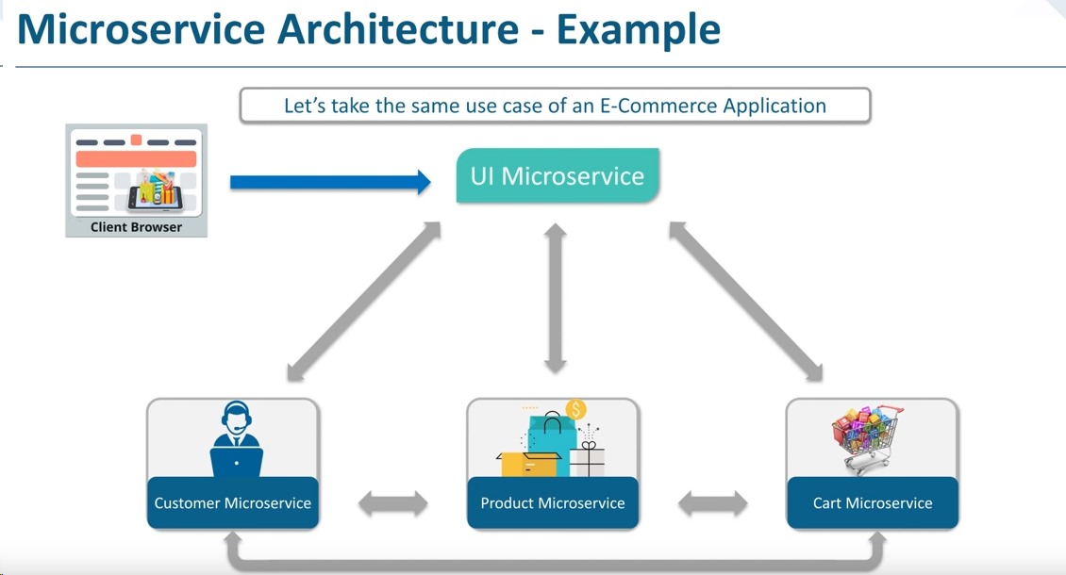

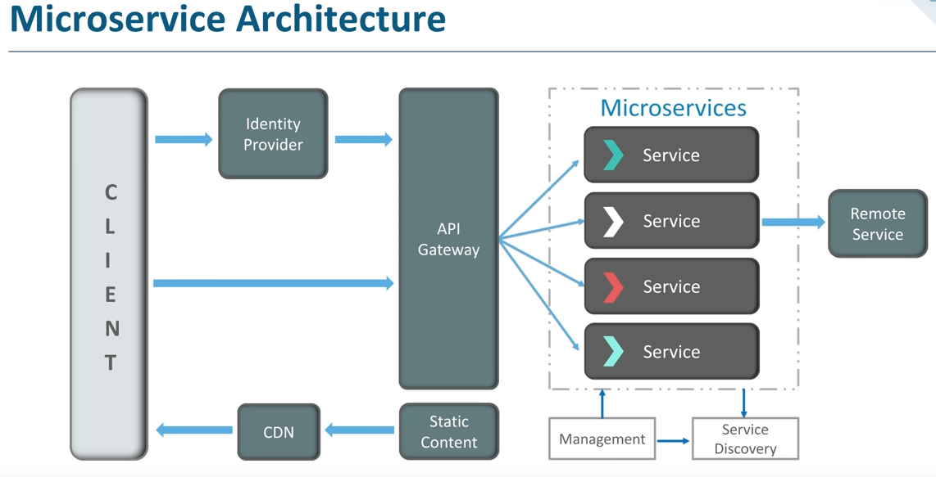

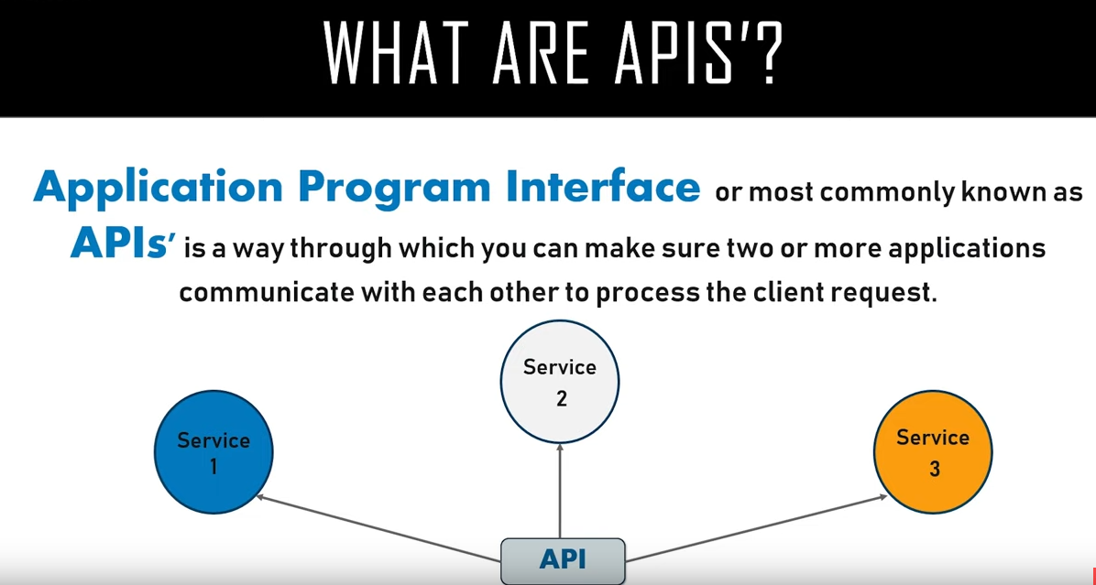

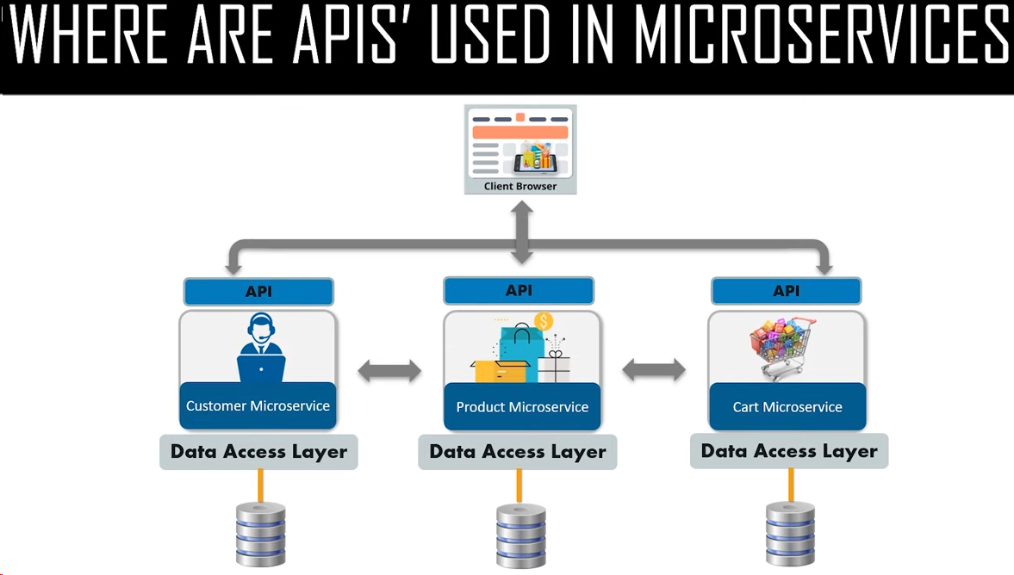

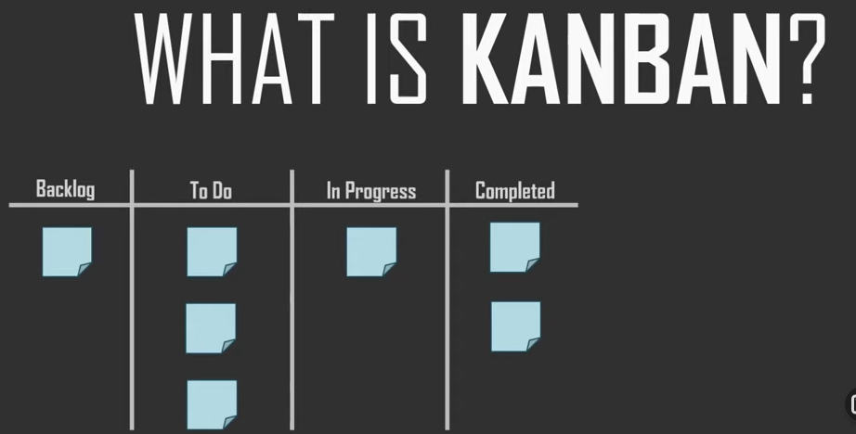

echo 'jenkins ALL=(ALL) NOPASSWD:ALL' >> /etc/sudoers

**big query project**

